Project Report for Database

Group Project:

Computer-based Inventory System Of

Desa Mart Sdn.Bhd Parit Raja

Distractors

by

1. MOHAMAD SYAFIEQ BIN MOHAMED (AI160010)

2. TOONG YEE KHEI (AI160181)

3. NG XIAO ZHEN (AI160197)

4. SITI UMATUSSHOLIKHAH BINTI DARSONO (AI160015)

5. KHALPHANADEVE A/P P.RAMACHANDRAN (AI160217)

A thesis submitted in partial fulfilment of the requirement for the award

of the Degree of Master of Computer Science (Multimedia)

Faculty of Computer Science and Information Technology

University Tun Hussein Onn

April 2018

**Table of Content**

|  |  |
| --- | --- |
| **Content** | **Pages** |
| TABLE CONTENT | **I** |
| CHAPTER 1: INTRODUCTION | **1** |
| 1.1 Desa Mart Sdn. Bhd. Background | **1** |
| 1.2 Problem Defining | **1** |
| 1.3 Objective of the Project | **2** |
| 1.4 Scope of the Project | **2** |
| 1.5 Justification of the Project | **3** |
| CHAPTER 2: CLIENT’S PROFILE | **4** |
| 2.1 COMPANY PROFILE | **4** |
| 2.1.1 History of Desa Mart Sdn. Bhd. | **4** |
| 2.1.2 Location and Environment | **5** |
| 2.1.3 Vision and Mission | **5** |
| 2.1.4 Desa Mart Sdn. Bhd. Organization Structure | **6** |
| 2.1.5 Desa Mart Sdn. Bhd. Products and Services | **7** |
| CHAPTER 3: PLANNING | **8** |
| 3.1 Introduction | **8** |
| 3.2 Software Process model adopted in the project | **9** |
| 3.3 Select an organization as a model (real world model) | **11** |
| 3.4 Project Planning | **12** |
| 3.4.1 Feasibility Study | **12** |
| 3.4.2 Planning | **14** |
| 3.4.3 Gantt Chart | **15** |
| CHAPTER 4: ANALYSIS | **18** |
| 4.1 Basic Concept and theory | **18** |
| 4.2 Data Gathering | **20** |
| 4.2.1 Method Carried Out for Data Gathering | **21** |
| 4.2.1.1 Interview | **22** |

|  |  |
| --- | --- |
| 4.2.1.2 Observations | **24** |
| 4.3 Current Project at Desa Mart Sdn. Bhd. | **25** |
| CHAPTER 5: DESIGN | **26** |
| 5.1 Introduction | **26** |
| 5.2 Design | **27** |
| 5.2.1 System Flowchart (Proposed System) | **27** |
| 5.2.2 Database Design (ERD & Related Notation) | **28** |
| 5.2.3 Input Design | **30** |
| 5.2.4 Output Design | **35** |
| 5.2.5 Interface Design | **44** |
| CHAPTER 6: Project Implementation | **49** |
| 6.1 Requirement Specifications for Project Development | **49** |
| 6.2 System Implementation Process | **53** |
| 6.2.1 Database | **53** |
| 6.2.2 PHP coding | **56** |
| 6.3 Hardware and software requirements | **62** |
| CHAPTER 7: Maintenance | **63** |
| 7.1 Weaknesses of the system/project | **63** |
| 7.2 Future Endeavour in the Project | **64** |
| CHAPTER 8: CONCLUSION | **65** |
| 8.1 Achieving the Aims of the Programs | **65** |
| 8.2 Advantages of the system/ project | **66** |
| REFERENCE | **67** |
| **Attachment 1: Peer Evaluation** | **i** |
| **Attachment 2: Group Time Sheet** | **vi** |
| **Attachment 3: Turnitin Check Similarity less than 25%** | **vii** |

**CHAPTER 1: INTRODUCTION**

* 1. **Desa Mart Sdn. Bhd. Background**

The Desa Mart Sdn. Bhd. Branch in Parit Raja started to open their branch at Parit Raja start from three years ago. The company has another branch at Batu Pahat which is located at Parit Yaani town. The company opened the branch at Parit Raja because the people there usually have farm and poultry. Therefore, they need to find nearer shop to supply the animal feed and medicine. Before the branch at Parit Raja opened, the previous shop was a boutique. Therefore, the shop has tiles, clean and has a nice condition. Desa Mart Sdn. Bhd. provides farm animal feeds, medicines, cages, pet food, fish food and other animal supplements. The shop also provides chicks with various species which the customers can order so that they can start their own poultry and get the food for the chicks at the shop.

* 1. **Problem Defining**

After doing the research, it is found that the store does not have any inventory management system specially to keep their information and records. The owner manually writes down all the sales records in a book. This may cause less effectiveness and less secure to the store information. The lack of digital records will make it hard for the owner to search for a particular record. Owner and staffs will have a hard time finding any information and sales records on the products they sold. Besides, due to the manual records, it might increase security risks as manual records have a higher chance of getting stolen. It will also cause high costs for the owner to buy books to record the sales reports. The management will be affected and this will lead to a decrease in performance for the store.

* 1. **Objective of the project**

1. Create a system which can keep the order records, sales records and inventory information organized.
2. Built a system which can search appropriate information about the sales and inventory.
3. Help in increasing data security.
4. Allow the owner to check on the available stock before selling.
5. Improve the effectiveness in searching the order records, sales records and inventory of the product.
6. Minimize data inconsistency in the order records, sales records and inventory.
   1. **Scope of the project**

In this project, the system is computer-based because it is more reliable in storing large data. Computer-based system will allow the owner to easily create, read, update and delete the data. The system is offline to increase data security. The system will have the database to keep the order, sales and inventory records. For order record, it will have a clear list of date, invoice no, product ID, quantity of ordered stock, supplier, product price and total price in ordering stock. The designed system will show the sales records of the store. For sales record, it will have a clear list of date, receipt no, product ID, quantity of product bought by customer, product price and total price to pay of sales. For the inventory, it will have a clear list of product name, product ID, category, number of stock and suppliers. The owner can search any characteristics of the product and the system will list it out. The system will also list out the product ID of the store’s inventory alphabetically. Besides, the system will sort the order record by invoice no and sales report by receipt number which will allow the owner to search for a particular sales record or order record easily.

**1.5 Justification of the project**

Since the recording of sales records of the store that is involved in this project is manual, the end discussion is to build a computer-based inventory system which can help boost the store’s management by increasing the effectiveness of the store. We will learn how to create a database and discuss the techniques used to implement the system of the program. The aim of this project is to study the importance of analyzing the current manual system and implement a database system which can improve the effectiveness in management. The analysis of this information leads to the development of a concept for a new inventory database system. The system is designed and built based on the issues, for example, the observed store does not have an organized database system which cause less performance in management. Since it is generally known that the database can be search and retrieved very quickly without having to manually check the list to see because it shares collection of logically related data and a description of this data, designed to meet the information needs of an organization, so a computer-based inventory system is developed to solve the issues.

**CHAPTER 2: CLIENT’S PROFILE**

**2.1 Company Profile**

The company that was involved in our project study is Desa Mart in Parit Raja which is one of the branch stores from DESA MART SDN.BHD. The main product sold in this store is animal feeds for live stocks and they sell products in bulks and also in retails.

**2.1.1 History of Desa Mart Sdn. Bhd.**

The manager of the company is Mr. Lee Wai Kok. He is the pioneer of the company. He starts to sell animals feed from a small shop in a district of Pahang. Many farmers and poultry owners come to the shop to get the supplement and foods for their livestock. He got the idea to make a branch of the shop based on where there are lot of farmers live. Therefore, he started to develop the shop from branch to branch until the Parit Raja branch is opened for the farmers there to easily get their livestock needs. Mr. Lee choose to sell the animals food and supplement because on that time, there are less shop that provides the feed and supplement for animals. Besides that, he got some friends that can provide him the animal feeds and supplements for lower price. Therefore, he sells the animals feed for the farmers.

**2.1.2 Location and Environment**

The shop located at No. 1 Tingkat Bawah, Jalan Cempaka Biru, Parit Raja, 86400 Batu Pahat, Johor. It is a hidden building behind the main road. The location of shop is quite convenient because it is located at the end of the building. Therefore, it is easier for the customers to park their vehicle and lift the 50kg of animal feed to their vehicle. Around the shop are food stalls, family karaoke, mobile top up shop, Cool Blogs, Guardian and Maybank. But, as the building is quite hidden, only farmers know the location of the shop. The shop is suitable for business based on the location of the shop which is at the ground floor and the corner of the building. But the location of the building is not that strategic as the shop hidden from the main road. Therefore, there will be less people who realize that there is an animal feed supplier there. Furthermore, the road is narrow over there, so larger vehicle will have a difficulty to reach the shop.

**2.1.3 Vision and Mission**

Table 2.1.3.1 Vision and Mission

|  |  |
| --- | --- |
| Vision | Mission |
| To provide the animal feed, supplement and medicine for livestock and pets for all animal lovers | To be the highest rating animal feed supplier in Malaysia in 2018 |

**21.4 Desa Mart Sdn. Bhd. Organizational Structure**

Table 2.2.5 Desa Mart Sdn. Bhd. Organizational Structure

|  |  |  |
| --- | --- | --- |
| Name | Position | Task |
| Lee Wai Kok | Manager | * Decide what to sell for every branch * Provides the stock for all branch * Monitor the sales of all branch * Give bonus for excellent branch |
| Ong Sui Chiau | Parit Raja Branch Leader | * Follow instruction of the manager * Find workers for the branch * Get the order of customer * Get the stock from nearest branch * Share excessive stock to nearest branch |
| Nur Airin binti Soekarjo | Cashier | * Monitor the branch profit and loss * Check the stock left * Audit current sales everyday * Count how many chicks send in the shop * Assist customer need |
| Siti Rahmah binti Mansor | Worker | * Clean the shop during opening and closing * Lift the animal feed to customer’s vehicle * Help the cashier put things in plastic bag * Packaging animal feed into various size of packets * Assist customer needs |

**2.1.5 Desa Mart Sdn. Bhd. Products and Services**

The shop sells various animals feed for cows, goats, rabbits, chickens, ducks, cats, dogs, birds and fishes. The supplement, medicine, bowls, cages and other pet requirements also provided. The main branch at Pahang will decide what to sell based on the people on the branch preferences. For Parit Raja branch, the people there focus more on livestock which is cat, chickens, ducks and rabbit feeds. Therefore, those animals feed have more stock at the shop. For pets, people of Parit Raja mostly interested in cat. Therefore, the shop provides cat cage, milk, foods, sands, shampoo, vitamin and other necessary things for cat. The shop provides lifting service for the customers. The 50kg animal feed will be lifted by the worker to the customer’s vehicle. Besides, the shop also provides chicks with various species weekly. The customers only need to tell the branch leader how many chicks they want. At the end of the week, the leader will provide the chick for the customer by taking it from another branch. The Parit Raja branch cannot sell chicks directly because people of Parit Raja usually already have their own chicken. Therefore, only those who need can order. Besides that, if no one buys the chick, the chick will grow up and the cashier needs to update the price. Moreover, for the product that near to expire date, there will be a lower price or promotion so that less thing will be destroyed later if the customer buys it. It is important to maintain the profit of the branch. Furthermore, the branches help each other by exchanging product. This is because different place got different preferences. So, if a product in demand in another branch, the other branches will send their product there so that the whole company can improve the profit and reduce loss. The workers will organize and record their sales manually in sales report and check the inventory manually and record all the information in a log book.

**CHAPTER 3: PLANNING**

**3.1 Introduction of the project**

In this project, students need to identify manual system in an organization or company and assists the company by creating a prototype system which can improve the company’s current systems to serve their business needs. The company that was involved in our project study is Desa Mart in Parit Raja which is one of the branch stores from DESA MART SDN.BHD. The main product sold in this store is animal feeds for live stocks and they sell products in bulks and also in retails. From the research that was carried out beforehand, it is found that the store does not have any information recorded digitally. They manually record sales and the staff will check for the availability of stock every day. It may be less effective when they want to find the record of the sales and check inventory. So, the aim of the project is to create a computer based inventory system which will help to safe-keep its records. The owner will be able to find past year records easily by using the system’s search engine. This also might help boost the effectiveness and in turn help the store keep their information more organized. In other words, this inventory system will keep all the information and records of the store more secure as it has improved backup and recovery services.

**3.2 Chosen software process model**

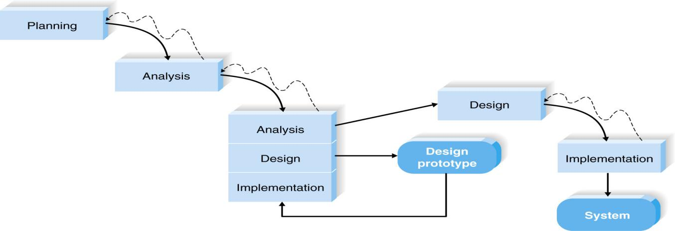

Figure 3.2.1 Throwaway Prototyping Model

The chosen process model is Throwaway Prototyping. It includes the development of prototypes but uses the prototypes primarily to explore design alternatives rather that as the actual new system. Design prototypes are not intended to be a working system. It contains only enough details to enable users to understand the issues under consideration. It is suitable for project with unclear user requirement and unfamiliar technology.

Throwaway Prototyping Model is especially useful when the project needs are in question and are vaguely laid out. It functions by providing proof that something can indeed be done in terms of systems and strategies.

Throwaway Prototyping Model is used for certain projects and will eventually be discarded after the project has been completed. It is also known as Close-Ended Prototyping.

Throwaway Prototyping Model is implemented through the creation of prototypes and thereafter gathering feedback from end users to check if they find it good or not. This is valuable to get a better understanding of the actual needs of users for the product or system development.

There are many reasons why project teams use Throwaway Prototyping model. For one thing, it is very cost-effective. Since Throwaway Prototyping model uses a series of prototypes to detect and forecast possible problems, it can prevent these from taking place as soon as the product or service is introduced to the user.

Problems are usually a very costly occurrence, and if you can keep them from happening, expenses can be reduced. Next, project completion is quick. Since it allows early detection of issues, the transition from one step to the next will be smoother and faster.

Lastly, when you use Throwaway Prototyping model, you can be assured that the end result is something that will certainly work because it has been thoroughly tested through the use of prototypes. The end product is expected to be able to meet the wants and needs of the target user.

**3.3 Select an organization as a model (real world model)**

SAP community is an organization that provide professionals a platform to connect, collaborate and built their reputations. This organization provide a lot of cloud and database platforms that are beneficial in business management system for instances like Data Warehousing, big data, SAP HANA and database and many more. One of the outstanding system that developed from this company is SAP IQ which it provides database services, application services, processing services, integration and quality services and Big Data optimization. This system can be a good reference for the inventory system that will be developed in this assignment since the SAP IQ covered services such as database services, multitier storage, data modelling, administration and security, high availability, web server, search function and inventory management.

The SAP IQ is one of a system that use in many company since it can accelerate the performance of extreme scale data warehousing more affordably. Besides, it can keep data private and secure more easily which this is one of the important traits in building a system. This can prevent the data loss or accidently leak out to public. Furthermore, without considering day and night, this system ensures the availability of extreme-scale data. Next, this system has highly flexible deployment options which it can supports most of the hardware and OS platform.

**3.4 Project Planning**

**3.4.1 Feasibility Study**

Feasibility study is essential in developing a system because it is used to determine the practicability of an idea which we need to ensure whether a project is worth the investment. There are three phases in this assessment which are technical feasibility, economic feasibility, operational feasibility.

Economic Feasibility

There is less cost in economic feasibility as the group only uses software that already owned. Furthermore, there also no training cost as the group already know how to use the software and the hardware.

Technical Feasibility

Technical feasibility will compare the existing system with the new system. The comparison is shown in the table 3.3.1.

Table 3.3.1.Technical Feasibility

|  |  |
| --- | --- |
| Existing System | New System |
| All inventory and sales report will be recorded in log book manually. The workers will check the stocks and update the data in the log book once new stocks is restocks. | Admin can create, read, update and delete the data from the database using the system. This system also allows admin to search the products by inputting the characteristics of products in search engine which can save lots of time. |

Organizational Feasibility

The new system can only be accessed by the staff as admin. It is created for managing the stocks data in inventory system. Besides, this system can keep all the sales records and admin can search the information about the sales and inventory needed. The workers can access the system anytime they want because this system will keep all the data secure and they can update the data when new stock is ordered. The system is created based on user-friendly concept which the workers can easily learn how to use this system to record the order record, sales record and inventory data digitally.

**3.4.2 Planning**

Project planning is part of project management, which relates to the use of schedules such as Gantt charts to plan and subsequently report progress within the project environment.

Project planning is at the heart of the project life cycle and tells everyone involved where the project is going and how it going to get there. The planning phase is when the project plans are documented, the project deliverables and requirements are defined, and the project schedule is created. It involves creating a set of plans to help guide the project team through the implementation and closure phases of the project. The plans created during this phase will help you manage time, cost, quality, changes, risk, and related issues. They will also help the project control staff and external suppliers to ensure that the project delivered on time, within budget, and within schedule.

The project planning phase is often the most challenging phase for a project manager, as it is needed to make an educated guess about the staff, resources, and equipment needed to complete your project. It may also need to plan the communications and procurement activities, as well as contact any third-party suppliers.

In this project, a database system is designed to keep the order, sales and inventory records of Desa Mart Sdn Bhd systematically after conducting initial research. We have decided to conduct an interview with the owner of Desa Mart to understand fully the issues that they face. We have provided the owner with a few selections of dates for the interview and prepared the interview question. All the team members are confirmed to be available on the few dates. It is decided that one day will be enough to conduct the interview.

After the interview, the team will analyze the interview and create a post interview follow-up. By using the report, each team members will set on analyzing and creating the design. Each team members will be given a specific task and execute their tasks accordingly.

**Interview**Final Project for Database

This interview is used for subject Database on reviewing the problem of the inventory system in Desa Mart Sdn Bhd in Parit Raja. All information given will be sworn on secrecy and will only be used in our assignment for the Database project.

1. What is the current inventory system used by Desa Mart Sdn Bhd？
2. Does the current inventory system work effectively in management?
3. What are the problems that Desa Mart Sdn Bhd is facing currently with the as-is system that you are using?
4. What is your opinion on the computer-based inventory system? Is it effective?
5. Does the company’s manager consider manage the inventory digitally?
6. Refer to question 5, if yes, what kind of inventory system the company needs? If no, why?
7. What is your opinion about the risk of managing computer-based inventory system?

**CHAPTER 4: ANALYSIS**

**4.1 Basic Concept and theory**

[Small](https://blog.resellerclub.com/why-is-promotion-important-for-a-business/) and [medium](https://blog.resellerclub.com/why-is-promotion-important-for-a-business/)-sized businesses really need to understand the importance of reliable database to keep all the information. Choosing a reliable database is an active process which needs to be very closely scrutinized for obtaining the best results. The database will help the company in many different ways such as increase effectiveness in management, keep all the records organized and obtain the required information easily. This in turn helps owner sort all the sales records and reports neatly. Database also enables the user to define, create, maintain, and control access to the database.

Basically, the database should be able to define the structure of database information, populate the database with appropriate information, manipulate the database and protect the database contents against accidental or deliberate corruption of contents[1]. The database designed should be able to define the structure of database information by defining descriptive attributes, data types and constraints all the while storing them as metadata. It also should be able to manipulate the database through CRUD functions which are Create, Read, Update and Delete. Besides, the database should involve secure access by the user and automatic recovery in the case of user or hardware faults.

After conducting the research, it is found out that the company Desa Mart Sdn Bhd, in Parit Raja that we chose to interview has a lack of a secure and effective inventory management. Furthermore, the company does all the sales recording manually in a book which can be easily misplaced or destroyed. So, it was decided to introduce a computer-based inventory system to the company that will allow the company to have a more effective and secure management of the store. These days, database can be one of the most effective storing data tools on the Internet as it has become a part of daily life for most, like to a school keeping the student records or police keeping criminal records. Through databases system, it is possible to store large number of records efficiently and they will take up less space[2]. Furthermore, the database system will allow the user to find, search, create, read, update and delete new and old information fast and easily. Records can also be sorted easily through newest to the oldest. And lastly, database system can be guaranteed more secure than traditional record keeping book.

This is the reason that it was decides to introduce the computer-based inventory system to the company as it is more convenient for the user to keep all the records safe and secure.

**4.2 Data Gathering**

Data gathering is the systematic approach to gathering and measuring information from a variety of sources to get a complete and accurate picture of an area of interest. [Data](http://searchdatamanagement.techtarget.com/definition/data) collection enables a person or organization to answer relevant questions, evaluate outcomes and [make predictions](http://searchsalesforce.techtarget.com/definition/predictive-analytics) about future probabilities and trends. Accurate data collection is essential to maintaining the integrity of research, making informed business decisions and ensuring [quality assurance](http://searchsoftwarequality.techtarget.com/definition/quality-assurance).

Data gathering is concerned with the accurate acquisition of data although methods may differ depending on the field, the emphasis on ensuring accuracy remains the same. The primary goal of any data gathering endeavor is to capture quality data or evidence that easily translates to rich data analysis that may lead to credible and conclusive answers to questions that have been posed.

Accurate data gathering is essential to ensure the integrity of the research, regardless of the field of study or data preference. The selection of appropriate data collection tools and instruments, which may exist, modified or totally new, and with clearly defined instructions for their proper use, reduces the chances of errors occurring during collection.

Distorted findings are often the result of improper data collection such as misleading questions on questionnaires, unknowingly omitting the collection of some supporting data, and other unintentional errors. This would lead to a skewed conclusion that may be useless.

The type of instrument used is depending on the data gathering method selected. So, in stage of data gathering is the most important step to complete a system as the system requirement and design are according to the data collected. Besides, the method to carry out data gathering also important as different method will has different data gathering that may affect the result of data collection.

**4.2.1 Method Carried Out for Data Gathering**

There are many methods for collecting data for performance measurement. Each method is useful for certain measurement tasks and less appropriate for others. Each method also has its own set of advantages and constraints but do not avoid a method because of its constraints. However, planning a data collection, we should consider constraints and how these constraints will be addressed. There may be a number of data collection instruments for any data collection method. The goal is to select the instrument that is most appropriate for your data.

The selection of data gathering method should be based on the identified hypothesis or research problem, the research design and the information gathered about the variables. The method of data gathering may vary according to degree of structure, quantifiability, obtrusiveness and objectivity. There are several methods to carry out data gathering for example questionnaire, focus group, interview, survey and more. A few methods were chosen in order to gather the data needs in finding the system requirement and design which is interview, survey and observation.

For interview, data are collected orally. The interviewer asks clearly defined, systematic questions. Usually questions are predetermined and limited to a specific topic. Sometimes there are additional questions asked to elicit a more detailed response.

Formal observation of users is an inexpensive method for discovering more about learners’ behaviors and uses of existing spaces. Observation is a method that made an [overview of gathering data from observation](https://learningspacetoolkit.org/needs-assessment/data-gathering-tools-2/observation/index.html" \o "Observation: Overview).

**4.2.1.1 Interview**

In interviews, information is obtained through inquiry and recorded by enumerators. Structured interviews are performed by using survey forms, whereas open interviews are notes taken while talking with respondents. The notes are subsequently structured for further analysis. Open-ended interviews, which need to be interpreted and analyzed even during the interview, have to be carried out by well-trained observers and/or enumerators.

Although structured interviews can be used to obtain almost any information, as with questionnaires, information is based on personal opinion. Data on variables such as catch or effort are potentially subject to large errors, due to poor estimates or intentional errors of sensitive information.

Interviews can be conducted in person or over the telephone. Interviews can be done formally, semi-structured, or informally. Questions should be focused, clear, and encourage open-ended responses. Interviews are mainly qualitative in nature.

Since it was needed to directly get the accurate information about the as-is sales recording system and the needs for their ideal computer-based inventory system from the owner of the Desa Mart Sdn Bhd Parit Raja, it was decided to use the structure interviews for our data gathering. As structure interview always operates within formal written instrument referred as interview schedule. It was also required to design the question to be asked prior to interview including the order of the questions. The question was asked orally in face to face.

First of all, the owner of the company was interviewed about their as-is sales recording system and does the system work effectively in management. After interview, it was known that Desa Mart Sdn Bhd is still using normal physical books which consist of recording the sales by handwriting. It is a very traditional way to record their sales and it is not much secure and effective. The problem they face now towards their current managing is that it is practically handwritten by the owner.

Next, the owner was asked about their opinion toward the computer-based inventory system and what is the needs in creating their computer-based inventory system if their company is interested in to implement the system. Through the interview, we know that the owner of Desa Mart Sdn Bhd realize that it is harder to search for a particular information in a handwritten sales record books. It takes a hard time to search for the sales record one by one in the books. In these modern days, people will more prefer to fast and effective solution, since computer-based inventory system contain database that can save a large amount of data, it helps the user to improved backup and recovery services. Besides, the system can help user to search the full information about the product and sales by using the searching function in the system. The owner considered for a computer-based inventory system to improve their effectiveness in inventory.

Although the company had considered about creating a computer-based inventory system, the problem is they are still using the current sales recording system that need to write manually. After interviewing them, the reason the company does not want to implement the computer-based inventory system is that they think there is a high risk for using modern technology. Most of the staff they hire are in the ages that are not experienced well in using computer. For them to learn it, they need more time to learn how to use the computer-based inventory system well. Even for the ones that know well in running a computer system also need time to learn how to use it as different company have different computer-based inventory system. Besides, questions about the suppliers were asked during the interview, but since the information about the suppliers in Desa Mart Sdn Bhd is confidential, the details about how the suppliers system works in the shop are unknown.

After gathering all the data from interview, it is concluded that the current sales recording and inventory system in Desa Mart Sdn Bhd does not work effectively in management because handwriting sales record book is not secure. People can easily take and see the sales and it will take time to search for a sales record. Although the manager was interested in implementing a computer-based inventory system, it seems like his workers will have a hard time operating the system.

**4.2.1.2 Observations**

Observation allows for the study of the dynamics of a situation, frequency counts of target behaviors, or other behaviors as indicated by needs of the evaluation. For instance, many people are uncomfortable when asked about prejudice. Self-reports of prejudice often bring biased answers. Instead, a researcher may choose to observe black and white students’ interactions. In this case, observations are more likely to bring about more accurate data. Thus, sensitive social issues are better suited for observational research.

Through observation, it is found out that the company does not have effective management. The staff will check the stock left every day and report to the owner. The owner then orders the stocks from suppliers for restock if needed. Besides, most of the sales records are kept manually and by observing, it is concluded this way is not secure. Although it can be said that the company suffer no loss in security but there is no guarantee it is safe. Through observation also it was found out that there might be 2-3 customers who usually come by to return the product they bought and the owner had to search the sales record book.

From this, it will be a waste of time to check inventory and sales records, it may affect the customer’s impression towards the company.

**4.3 Current Project at Desa Mart Sdn. Bhd**

Figure 4.3.1 Desa Mart Sdn Bhd - As-Is Sales Recording Process

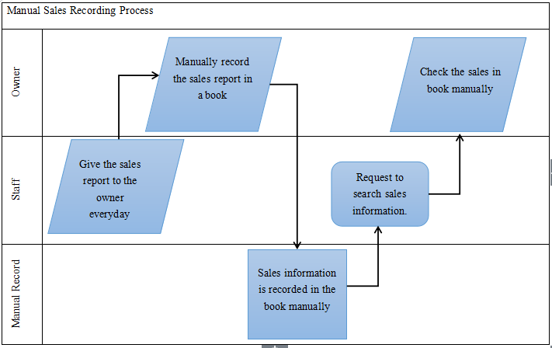

Figure 4.3.2 Desa Mart Sdn Bhd - As-Is Check Inventory Process

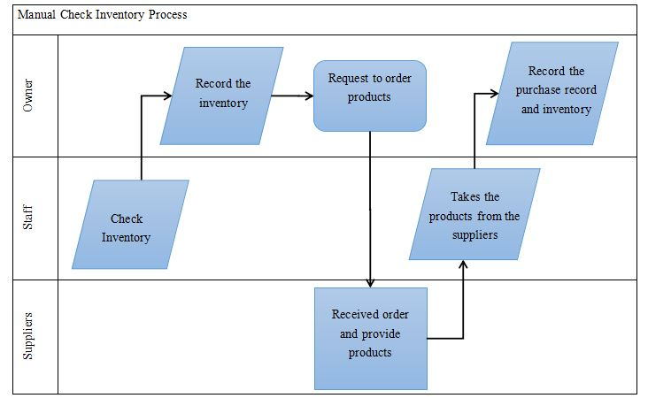

**CHAPTER 5: DESIGN**

**5.1 Introduction**

Based on the initial research, Desa Mart currently does not use any digital platform as a means of recording their sales and inventory. So, it is believed that Desa Mart will have an increase in management effectiveness by using computer-based inventory management system. This system will mainly be used by the owner who needs to keep the sales records and search for a particular record. The system will also allow the owner to check for the available stock in the store. The main purpose of this system is to keep all the records in the store secure and obtain a particular record easily. This system cannot be accessed by anyone except the owner. The design of the system was created by keeping in mind the requirement and accessibility of user.

**5.2 Design**

**5.2.1 System Flowchart (Proposed System)**

Figure 5.2.1.1 Flow chart of search engine

Figure 5.2.1.2 Flow chart of input inventory

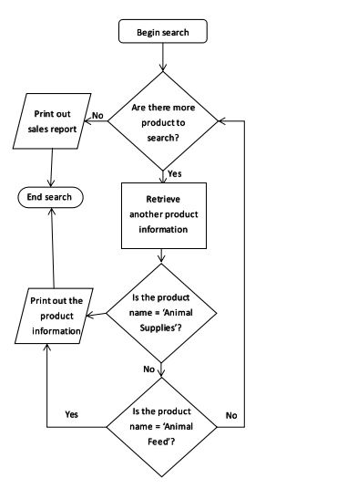

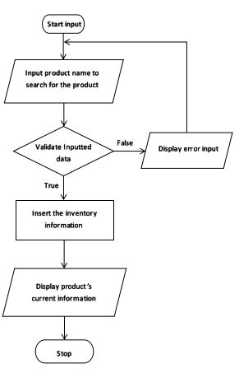

**5.2.2 Database Design (ERD & Related Notation)**

Figure 5.2.2.1 Context Diagram

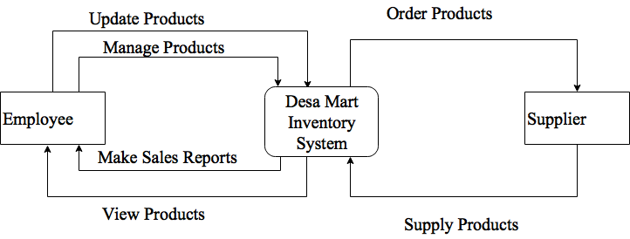

Figure 5.2.2.2 ERD Diagram

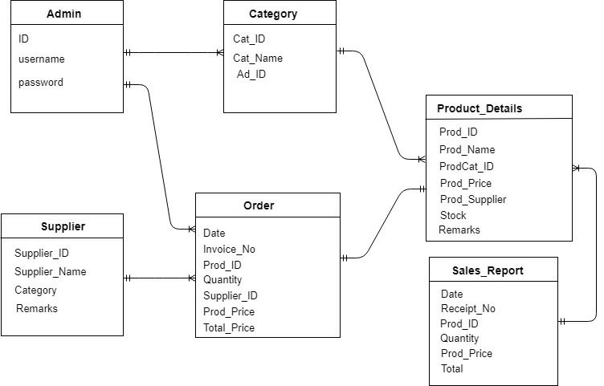

Figure 5.2.2.3 DFD Level 0 diagram

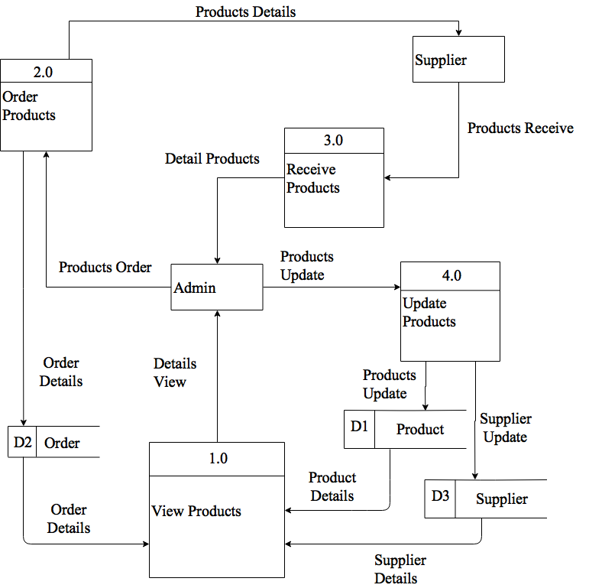

Figure 5.2.2.4 DFD Level 1 diagram

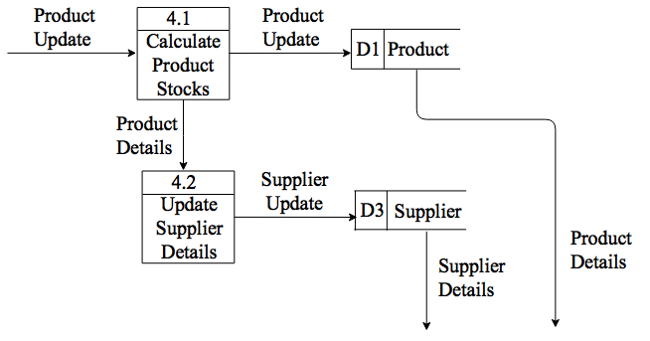

**5.2.3 Input Design**

Figure 5.2.3.1 Login Input Design

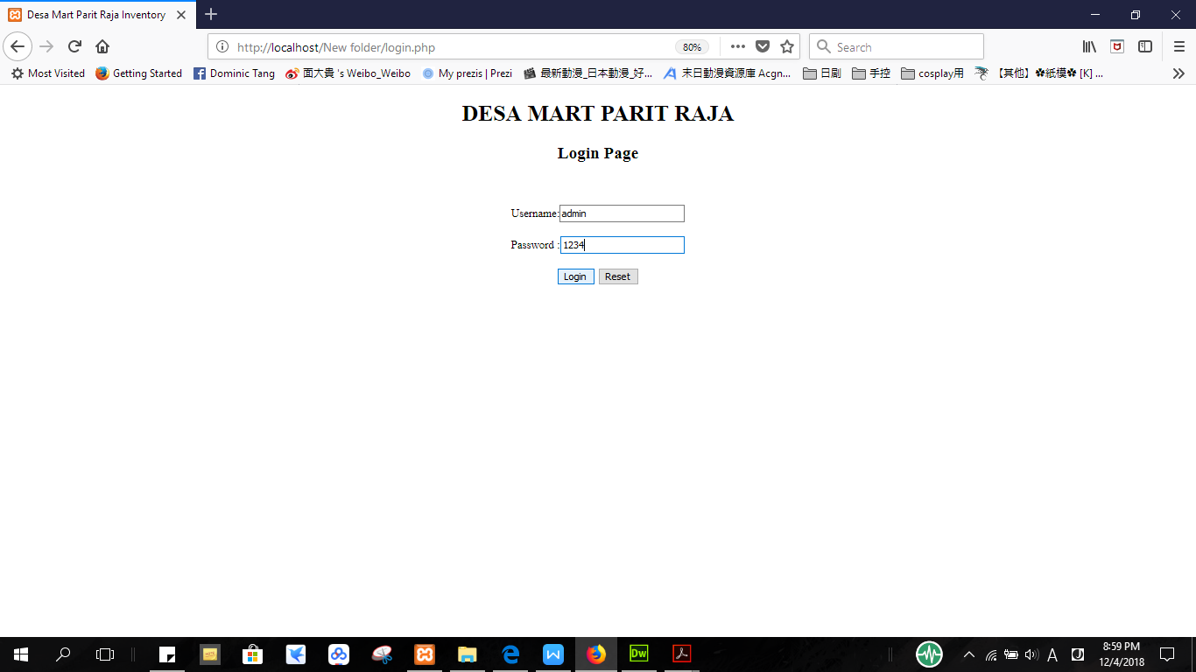

Figure 5.2.3.2 Home Input Design

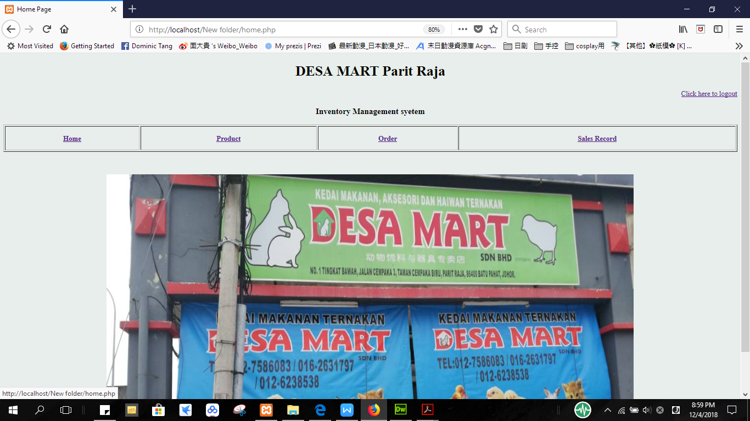

Figure 5.2.3.3 Logout Button Design



Figure 5.2.3.4 Product Interface Design

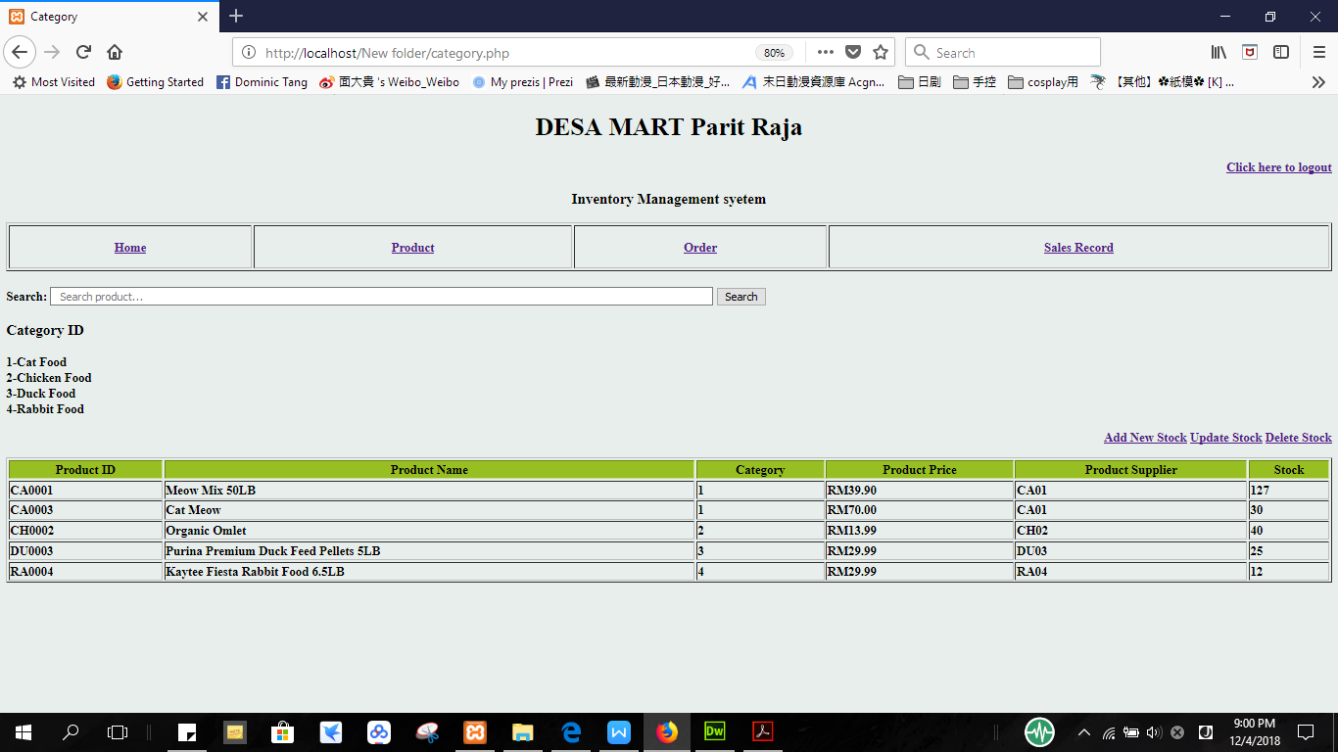

Figure 5.2.3.5 Search Engine for product

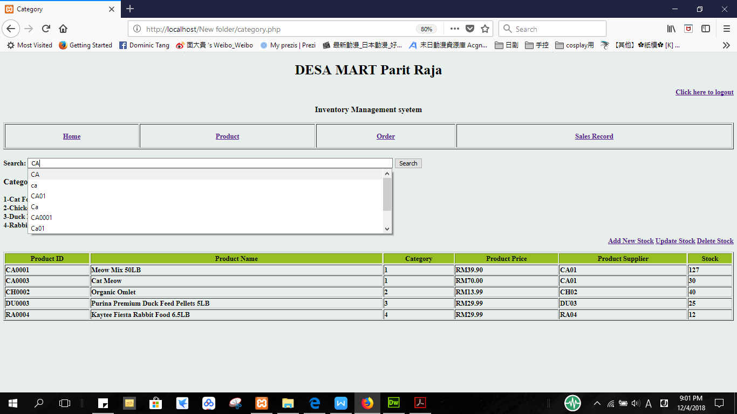

Figure 5.2.3.6 Add new stock for product



Figure 5.2.3.7 Update Stock for product



Figure 5.2.3.8 Delete Stock for product



Figure 5.2.3.9 Order Interface Design

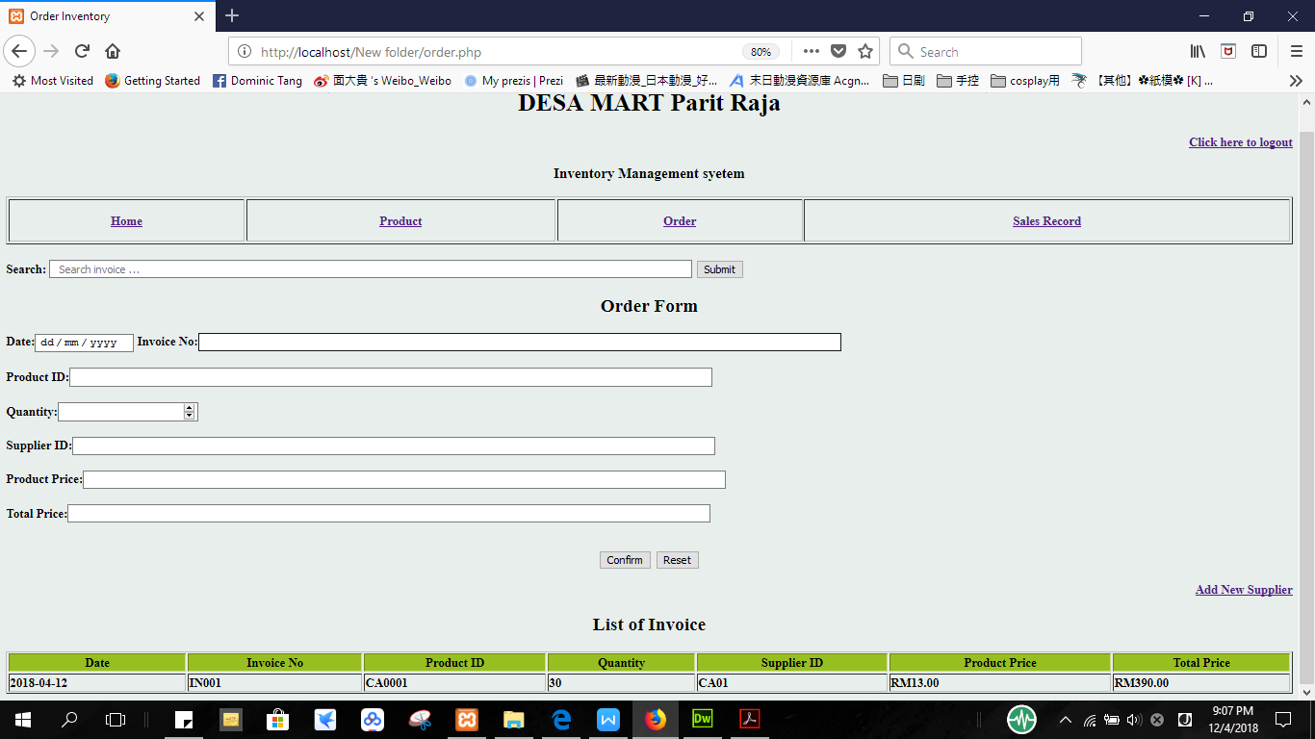

Figure 5.2.3.10 Add/Update New Supplier

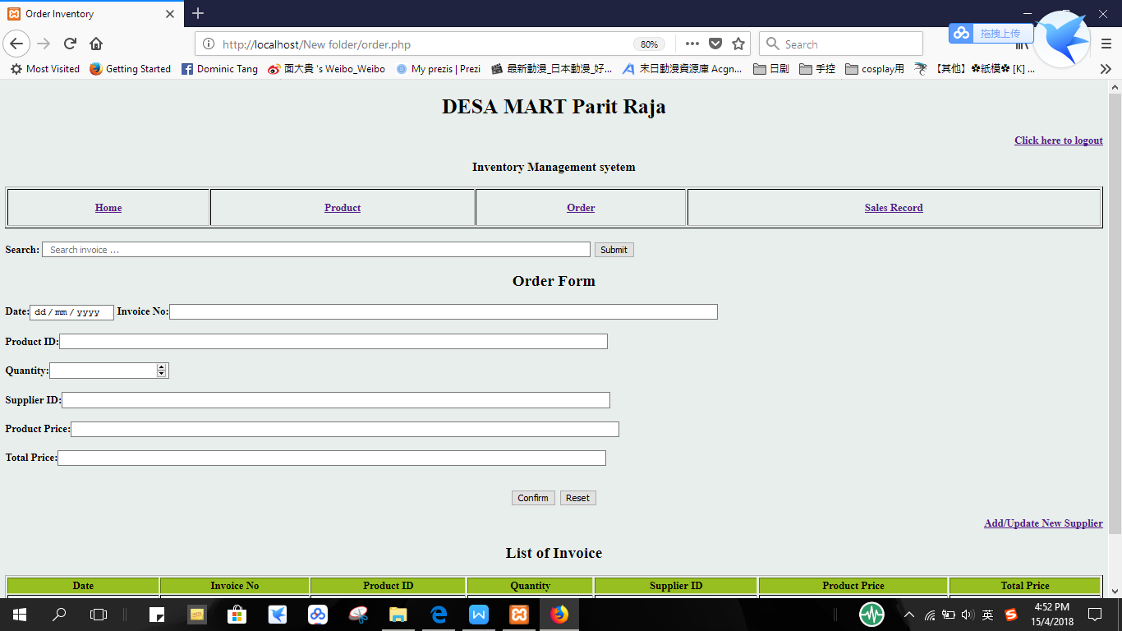

Figure 5.2.3.11 Search Engine for invoice

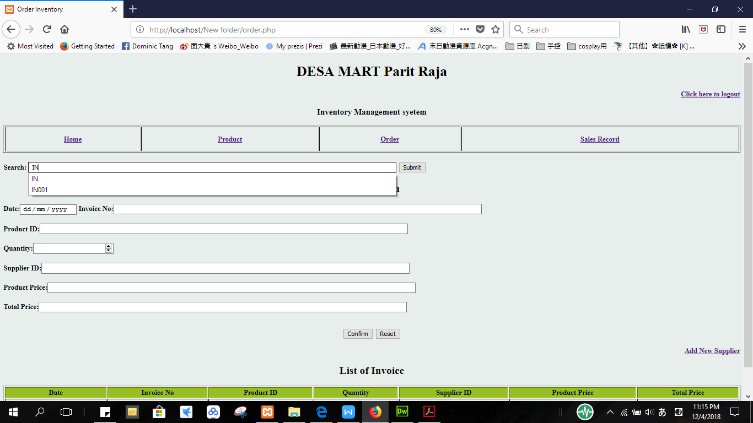

Figure 5.2.3.12 Sales Record Interface Design

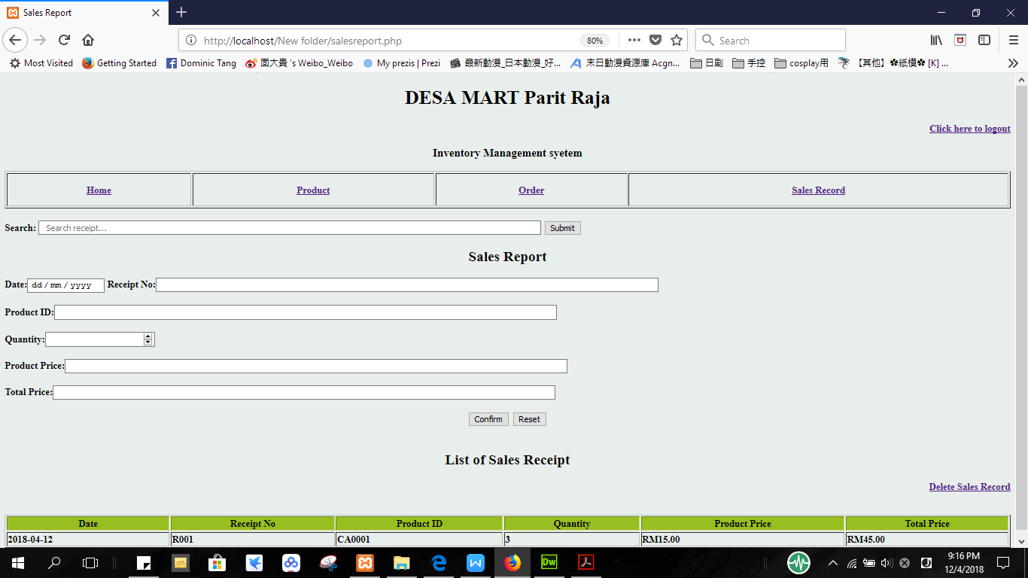

Figure 5.2.3.13 Search Engine for receipt

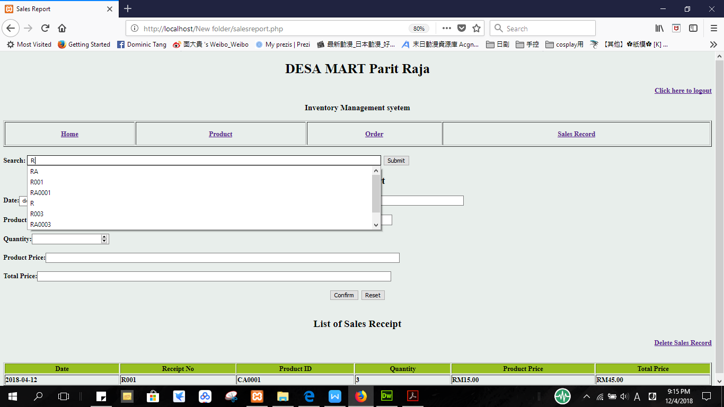

Figure 5.2.3.14 Delete Sales Record



**5.2.4 Output Design**

Figure 5.2.4.1 Output if user input wrong username

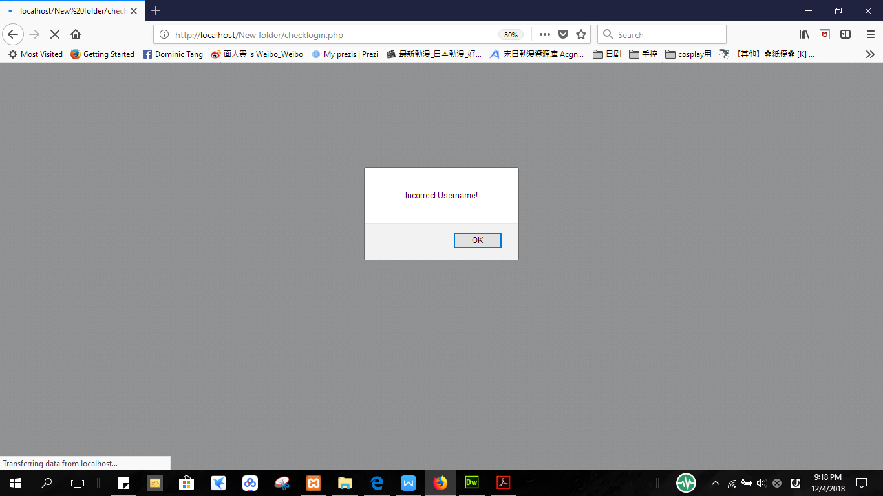

Figure 5.2.4.2 Output if user input wrong password

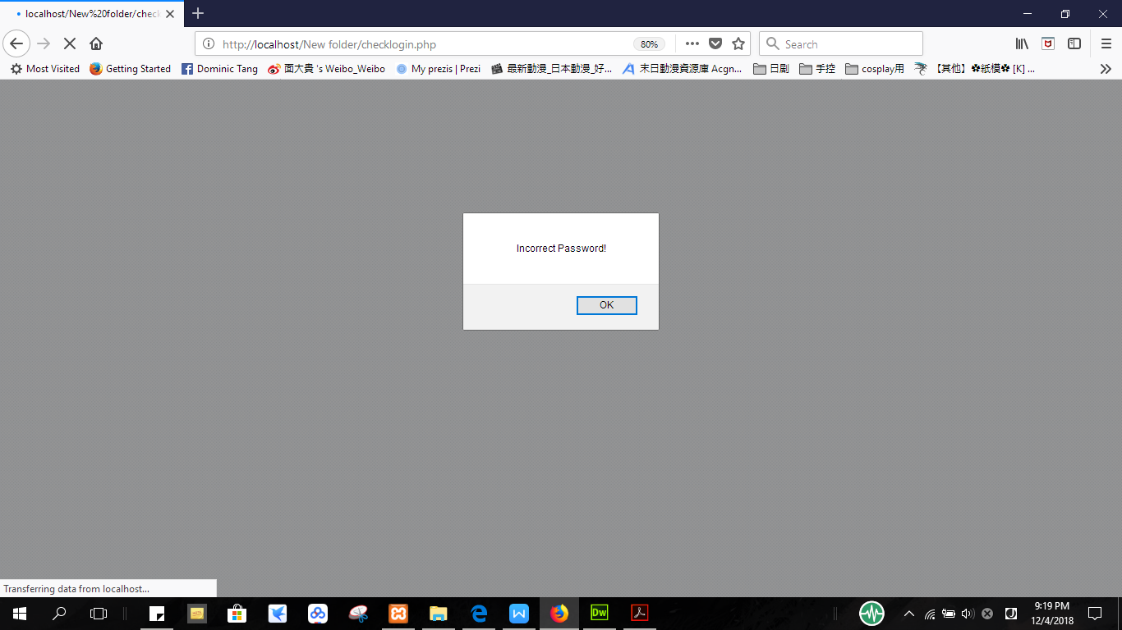

Figure 5.2.4.3 Back to login page user press OK from the alert window in Figure 5.2.4.1 and Figure 5.2.4.2

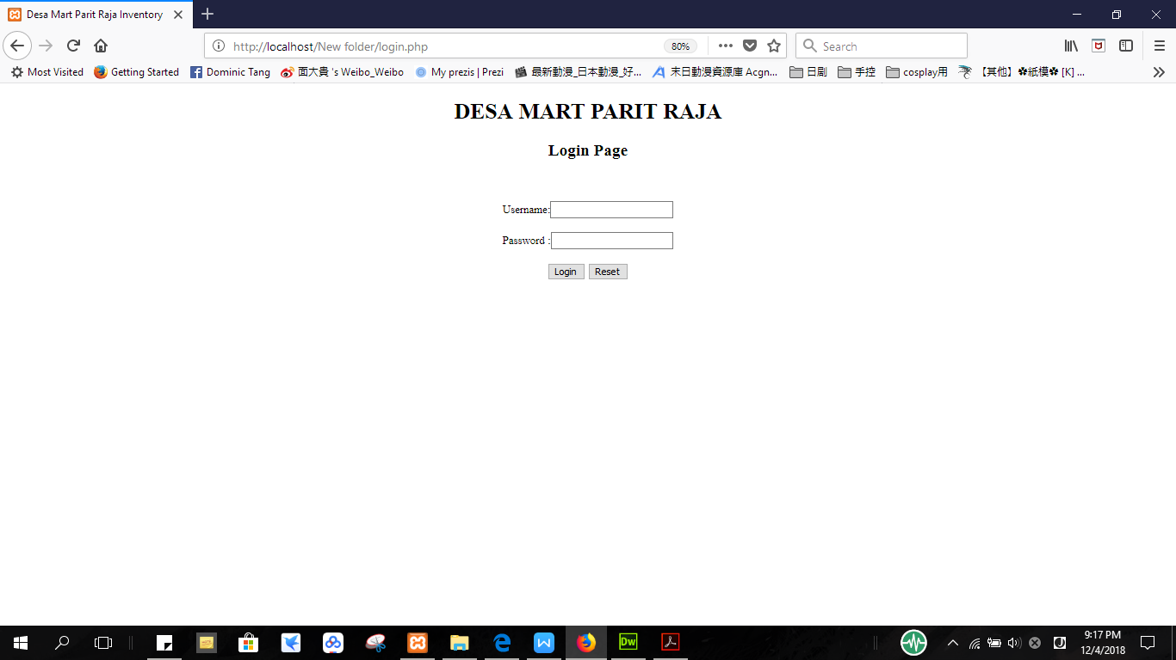

Figure 5.2.4.4 Output of the search result for product

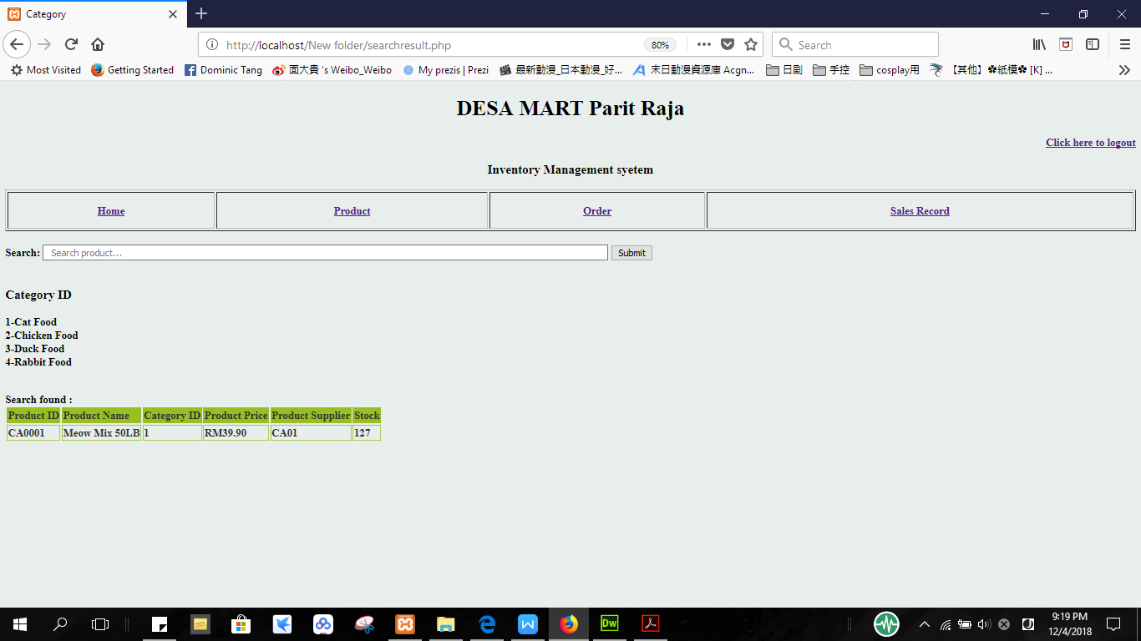

Figure 5.2.4.5 Output if data not exists in the table data from search

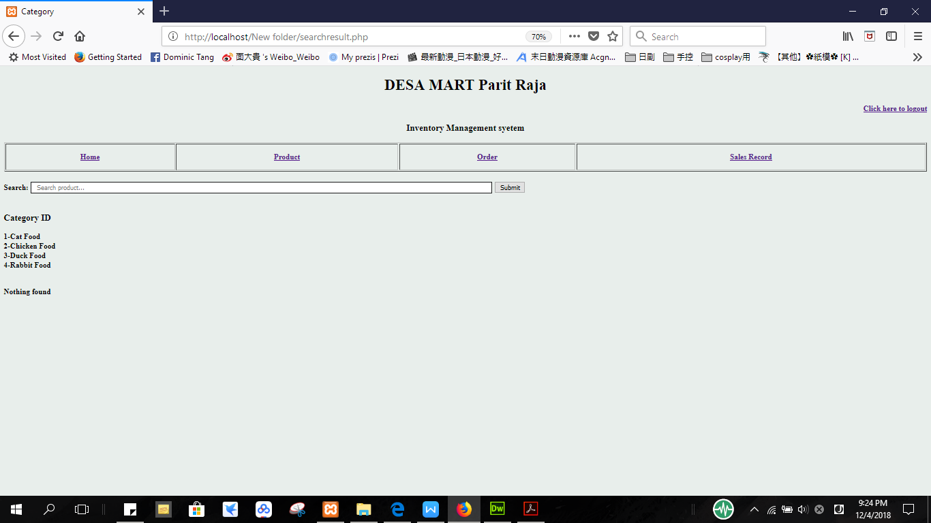

Figure 5.2.4.6 Add new stock

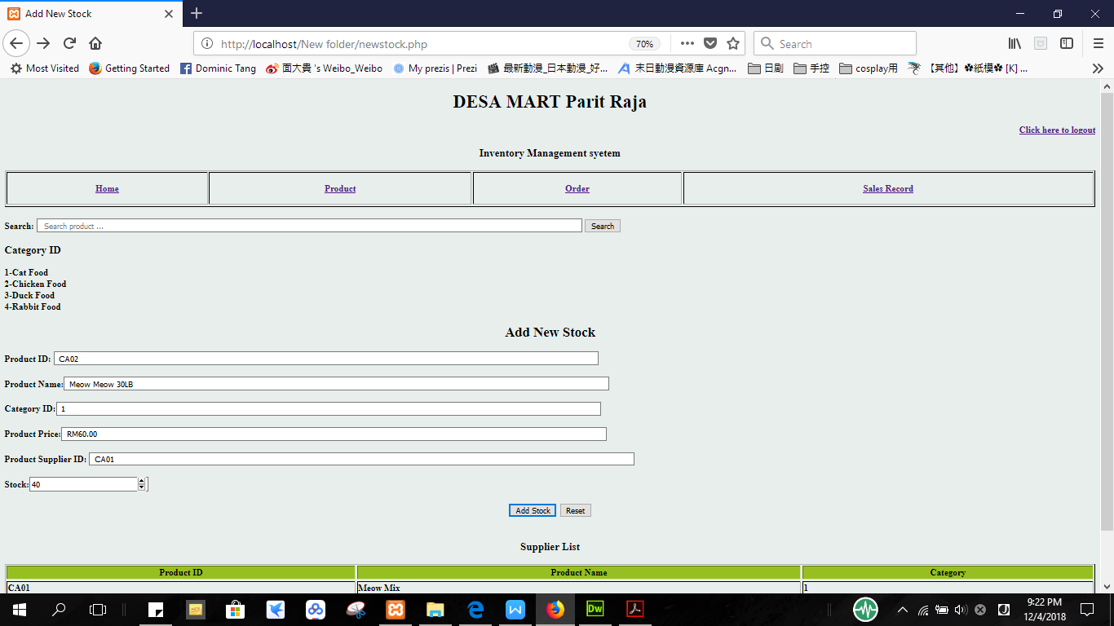

Figure 5.2.4.7 Output if users successfully insert new stock

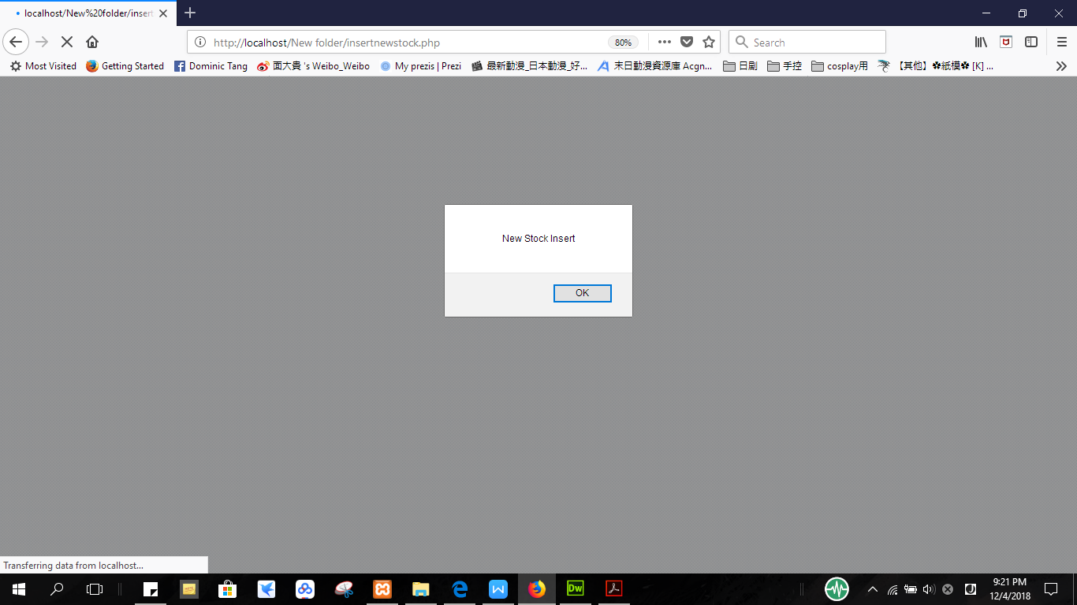

Figure 5.2.4.8 Output if user successful insert same product

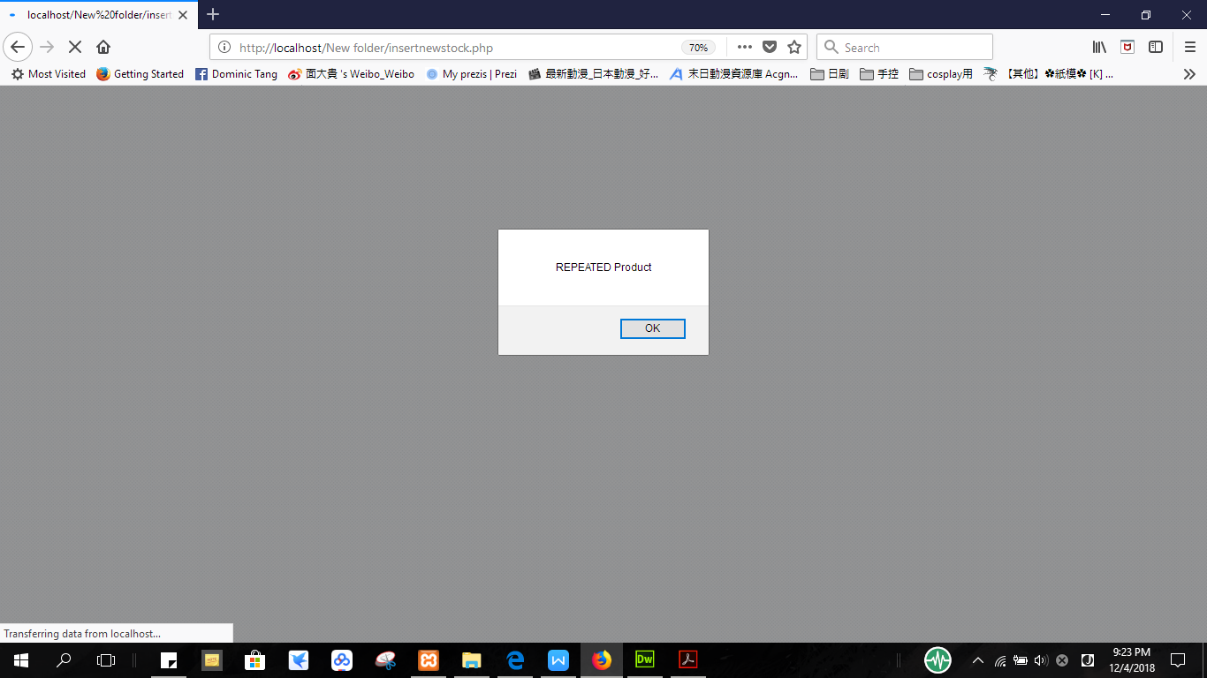

Figure 5.2.4.9 Update stock

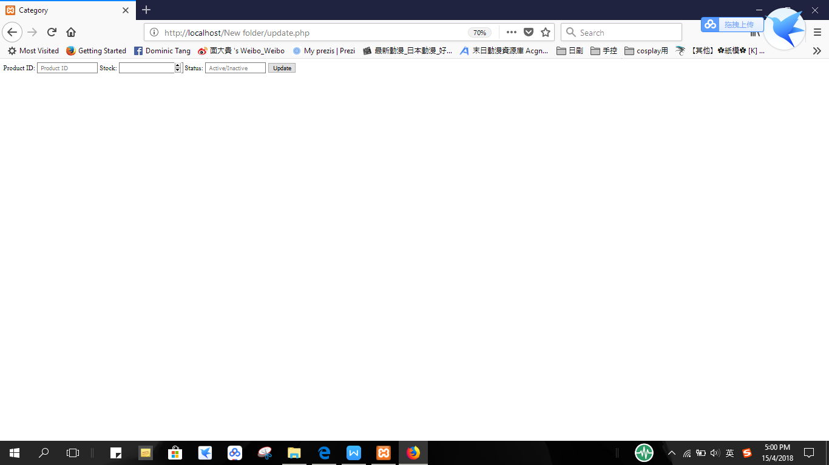

Figure 5.2.4.10 Output if user successfully updates stock

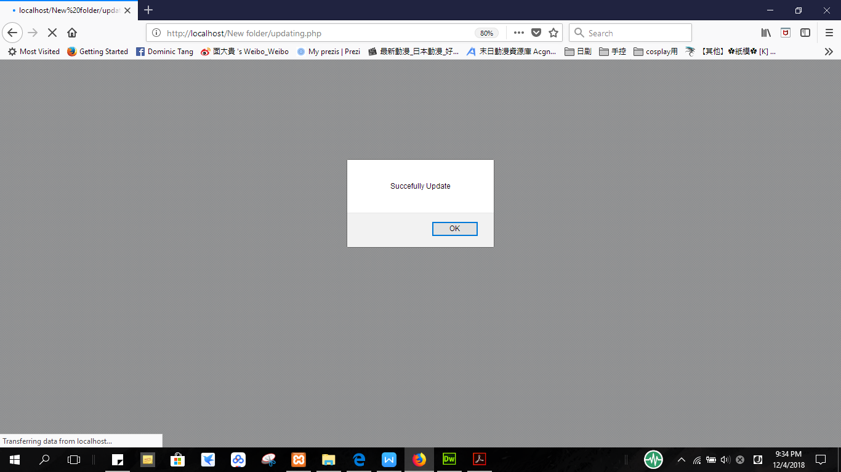

Figure 5.2.4.11 Delete Stock

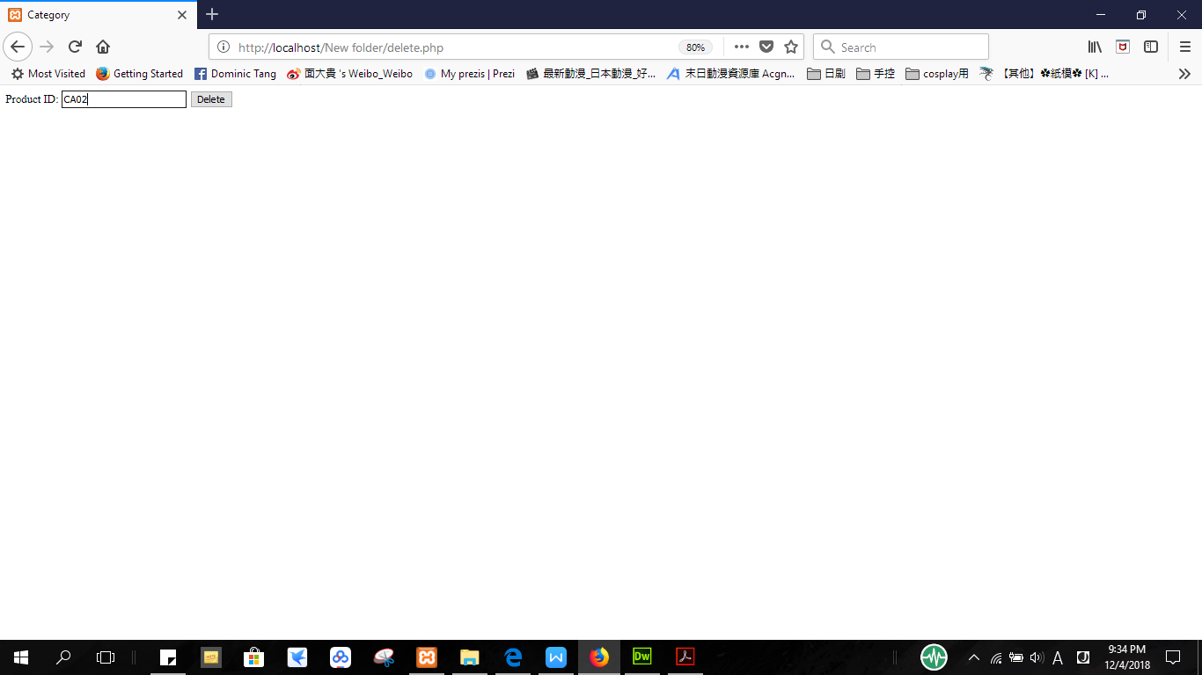

Figure 5.2.4.12 Output if user successfully deletes stock

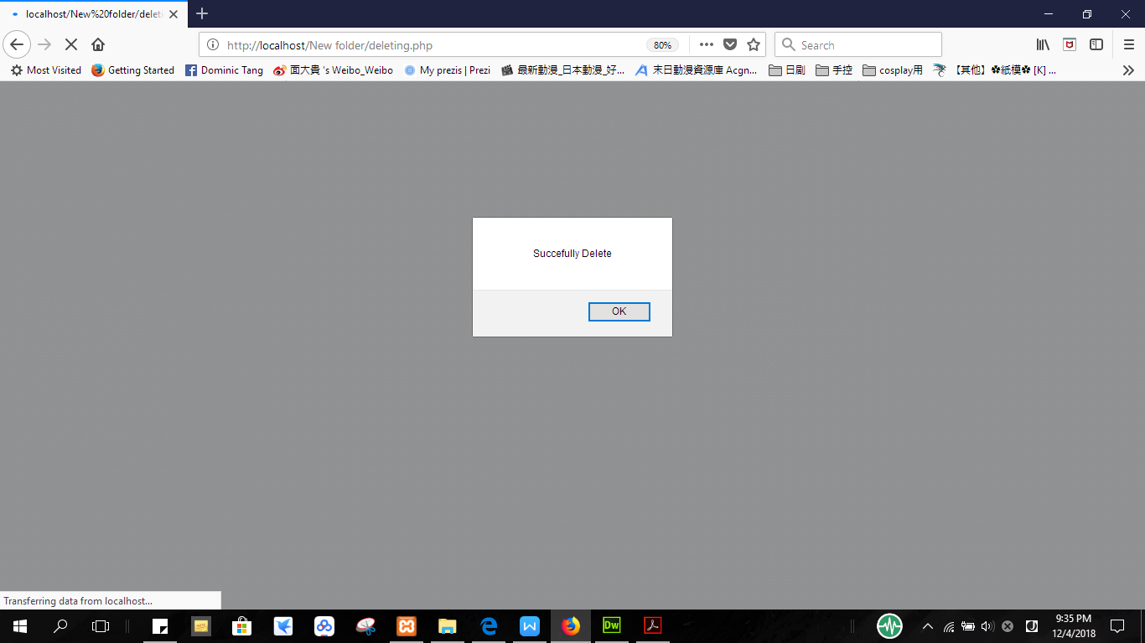

Figure 5.2.4.13 Output of the search result for invoice

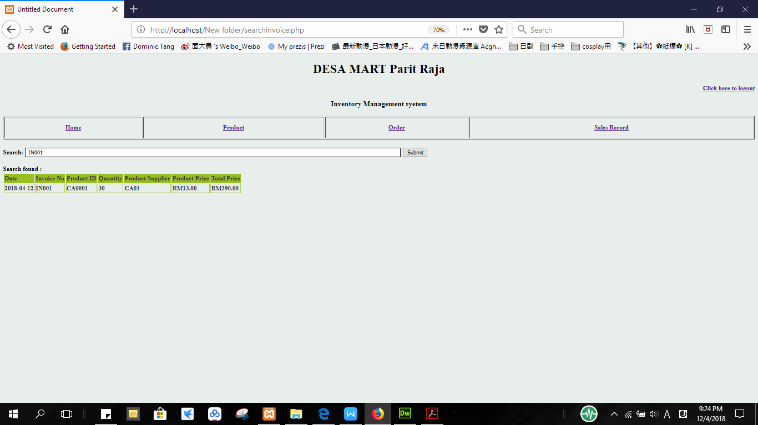

Figure 5.2.4.14 Insert new order record

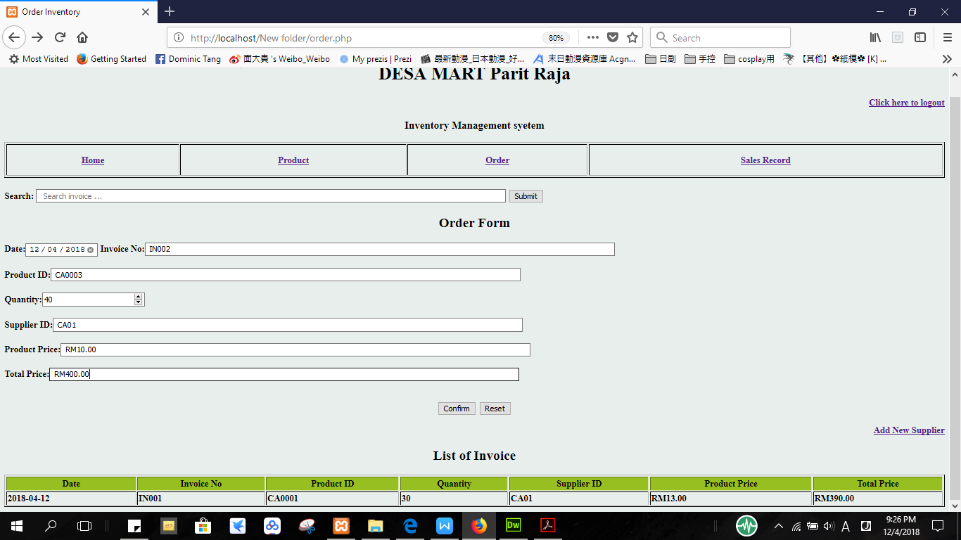

Figure 5.2.4.15 Output if user successful insert new order record

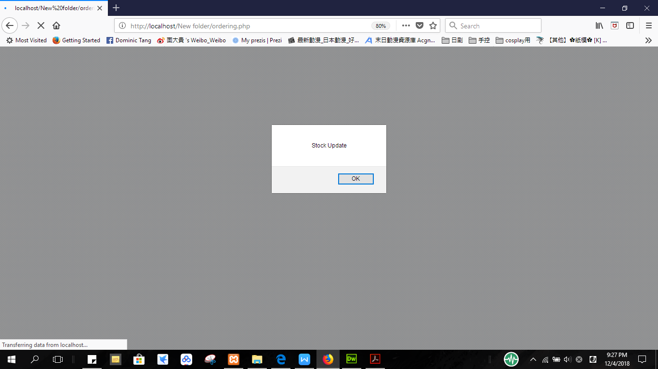

Figure 5.2.4.16 Output if user input same invoice information or quantity is equal to 0

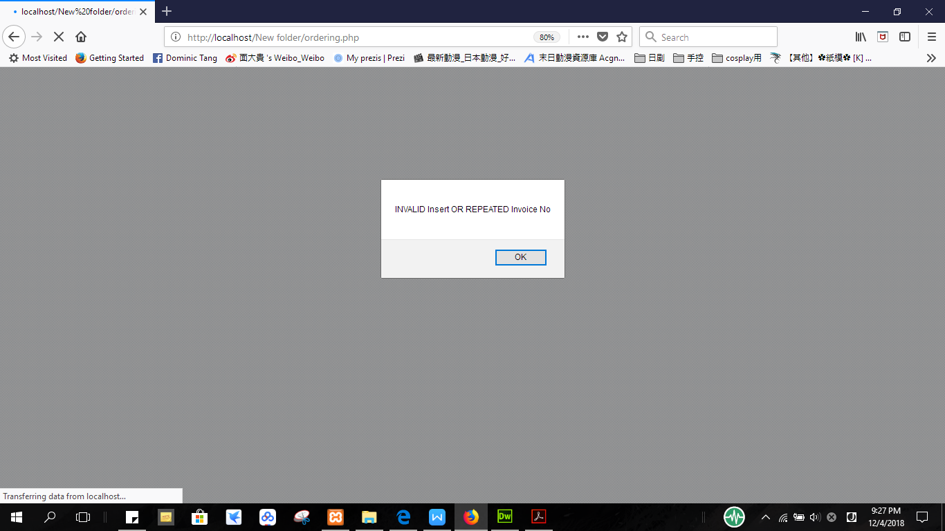

Figure 5.2.4.17 Add new supplier

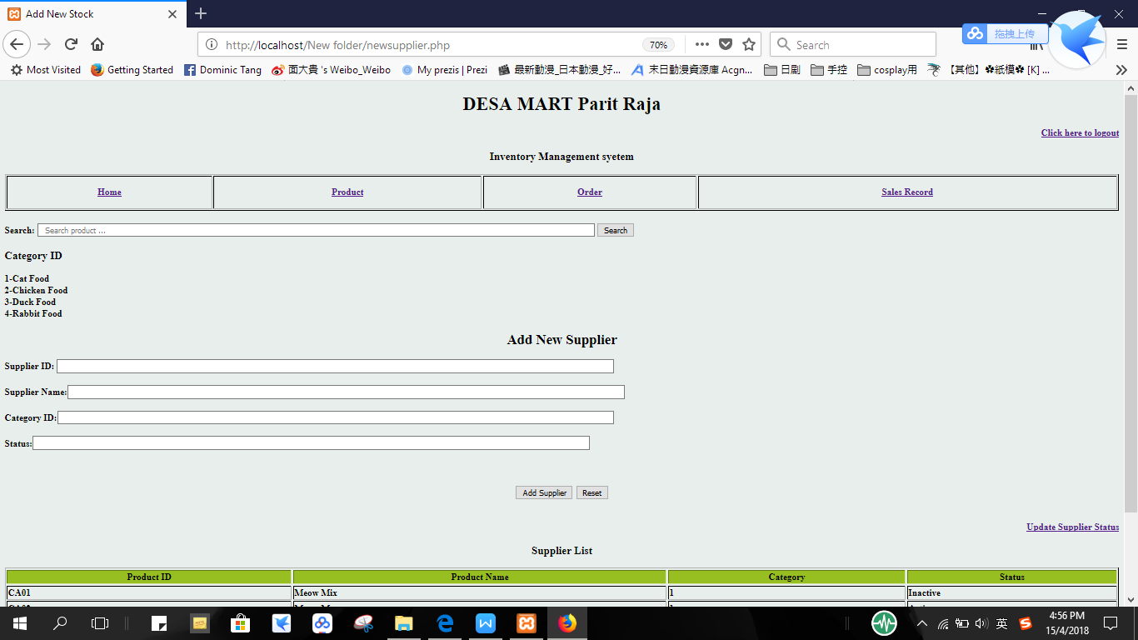

Figure 5.2.4.18 Output if user successful insert new supplier

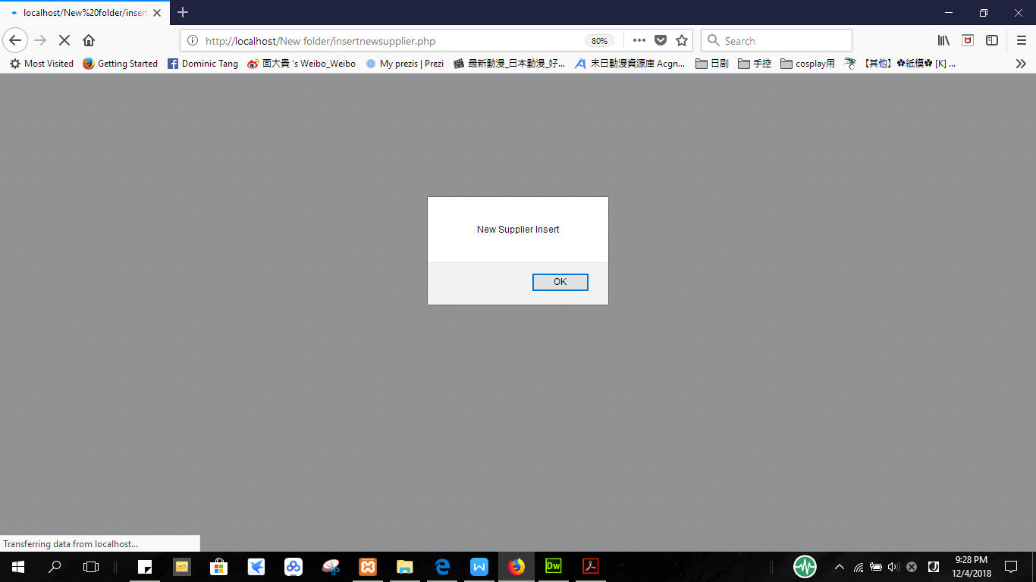

Figure 5.2.4.19 Output if user insert same supplier

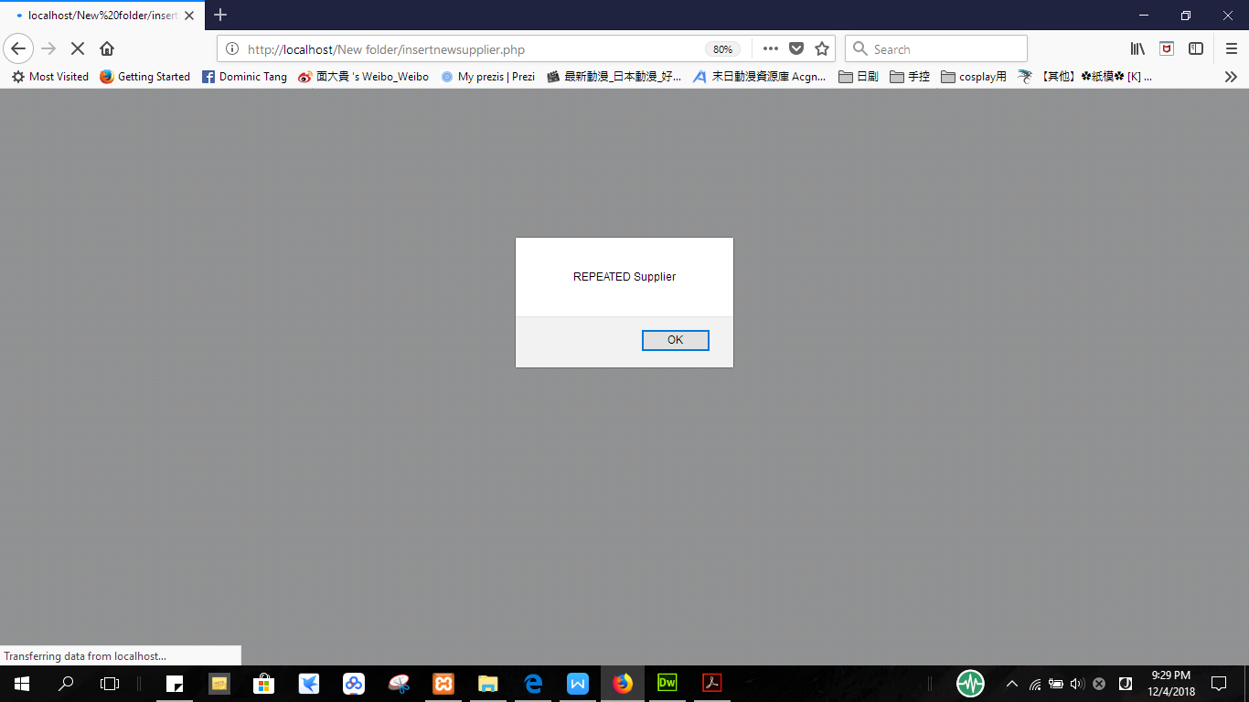

Figure 5.2.4.20 Update Supplier’s status

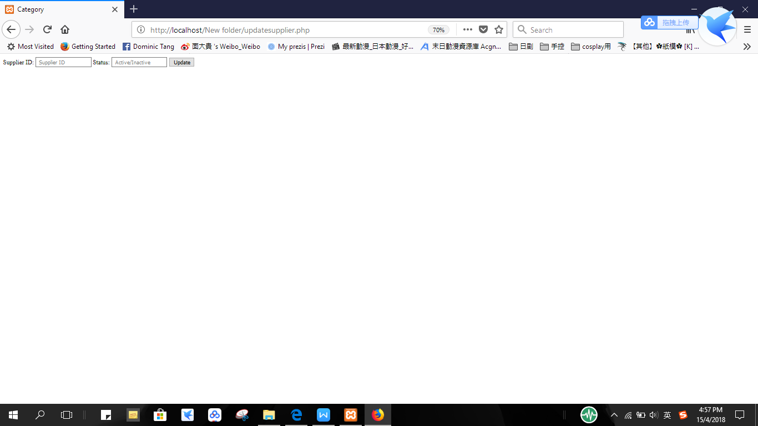

Figure 5.2.4.21 Output if user successful update supplier’s status

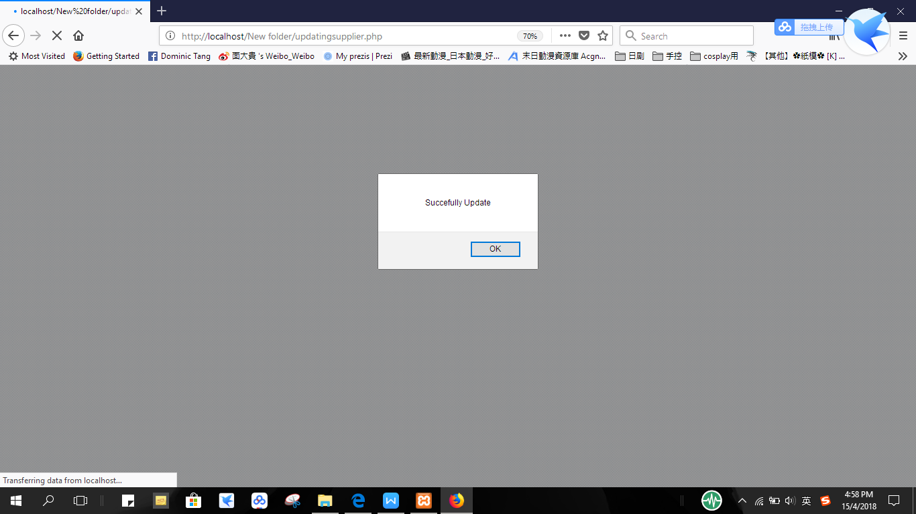

Figure 5.2.4.22 Insert new sales record

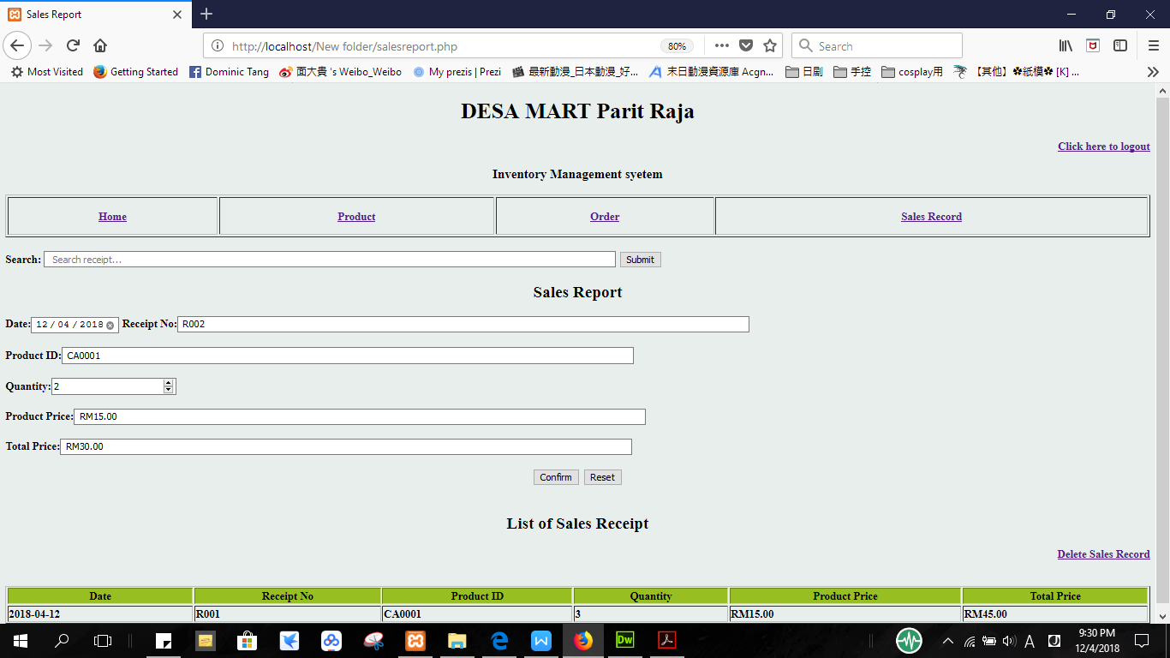

Figure 5.2.4.23 Output if user successful insert new sales record

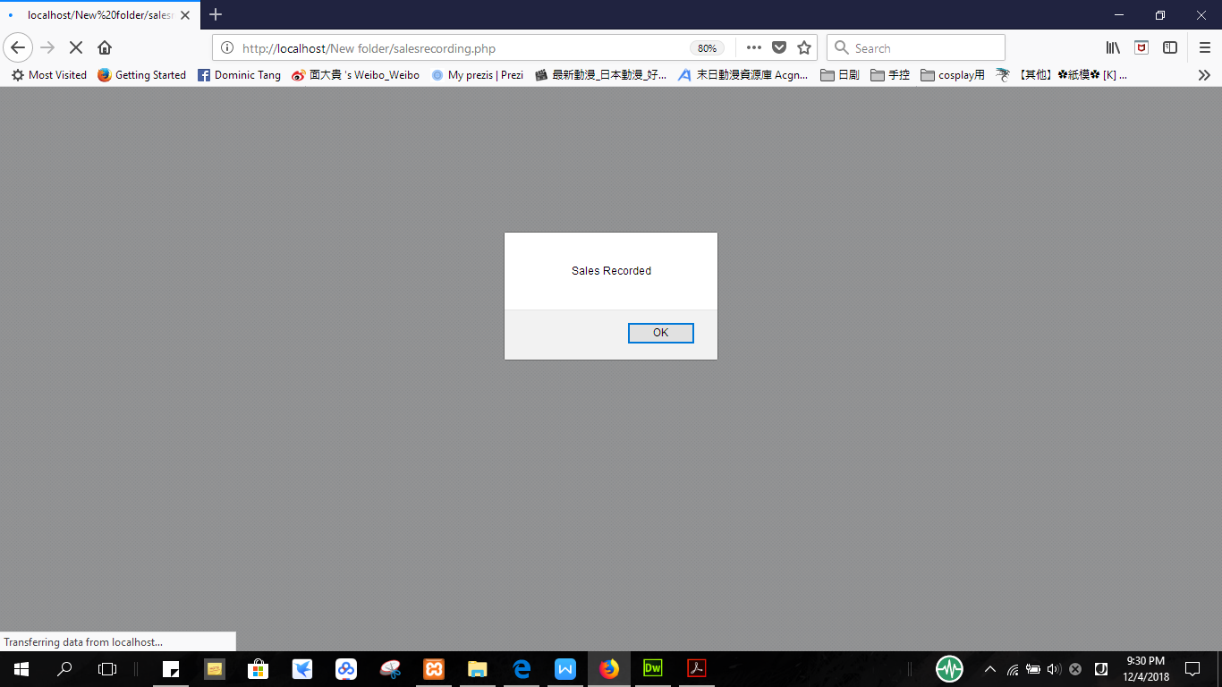

Figure 5.2.4.24 Output if user inserts same receipt information

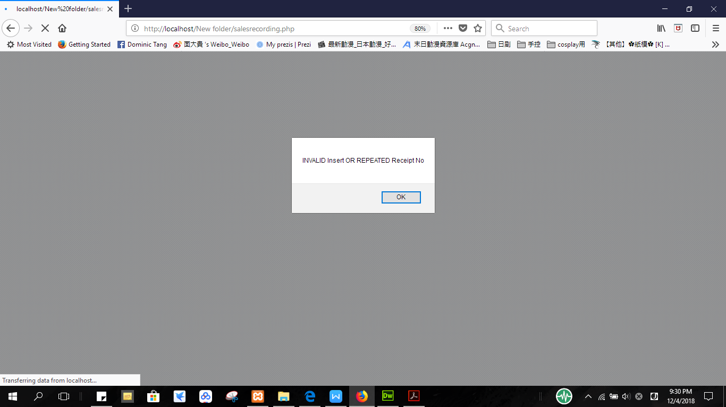

Figure 5.2.4.25 Delete Receipt

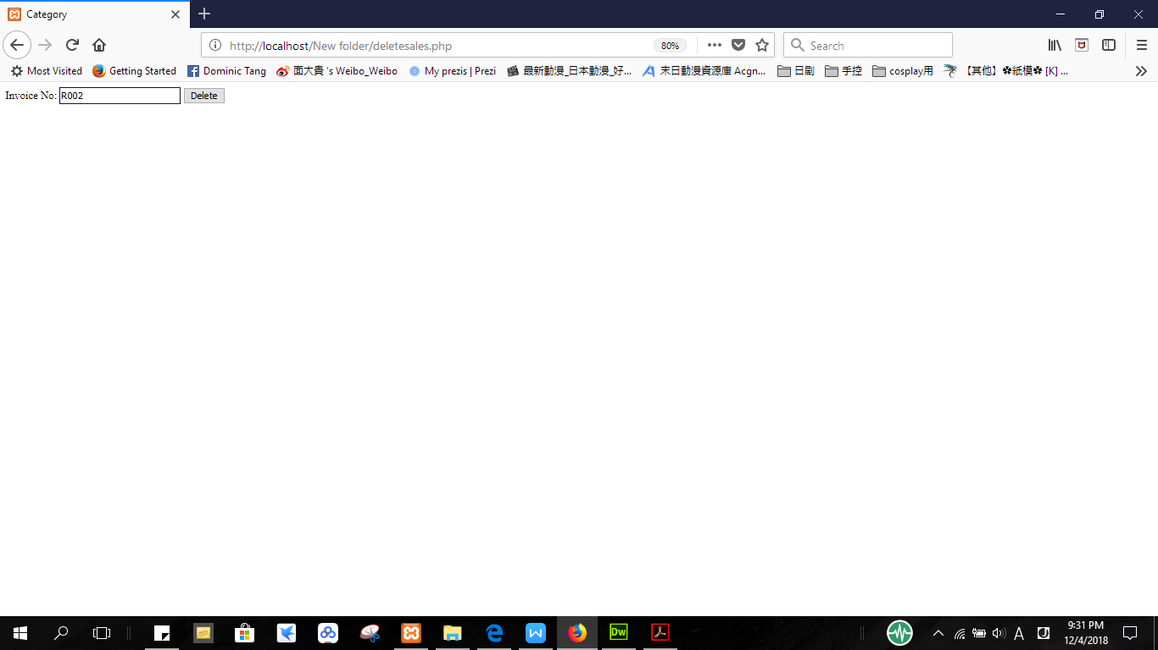

Figure 5.2.4.26 Output if user successful delete sales report

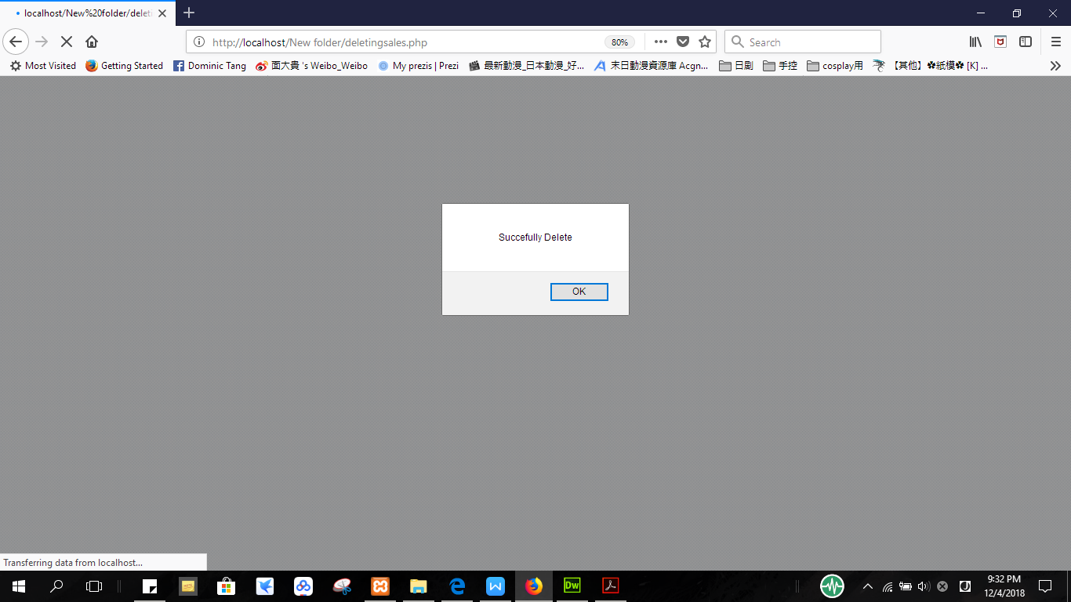

**5.2.5 Interface Design**

**5.2.5.1 Layout**

The layout of most of interface is consistent as seen in the above figures. The top consists of “Home”, “Product”, “Order”, “Sales Record”, “Search”, and “Click Here to Log Out” buttons along with the Company’s name and system’s name in most of interfaces. The top column is always the navigation panel for the categories menu and the middle part will change for all interfaces as it is the content.

**5.2.5.2 Aesthetics**

The design of the website is minimalist and ease to use. The Home page is simple with a title of company’s name and a photo of the company. The light blue background gives off a clean and refreshing style while the green highlight table data combination radiates positive emotions and friendliness that users are instantly lured into. Black color is used for the words in order to make them obvious and make the user go through less hassle. The color black immediately gives off a sophisticated style that is hard to resist.

**5.2.5.3 Consistency**

Most of the interfaces all have the same fonts, same placement of menus and all follows the colors mentioned before in order to create consistency.

**5.2.5.4 User Effort**

In this website, most of them follow the three-click rule. Three-click rule stands for the maximum number of clicks customers needed to before they are able to go from the start to the information they need. For example, as seen below in the figures below, to be able to view the product of the company, all the user has to click is the Product on the Home page after logging in. Then, the list of product will be shown and all it took is 2 clicks.

Figure 5.2.5.1 Login Page

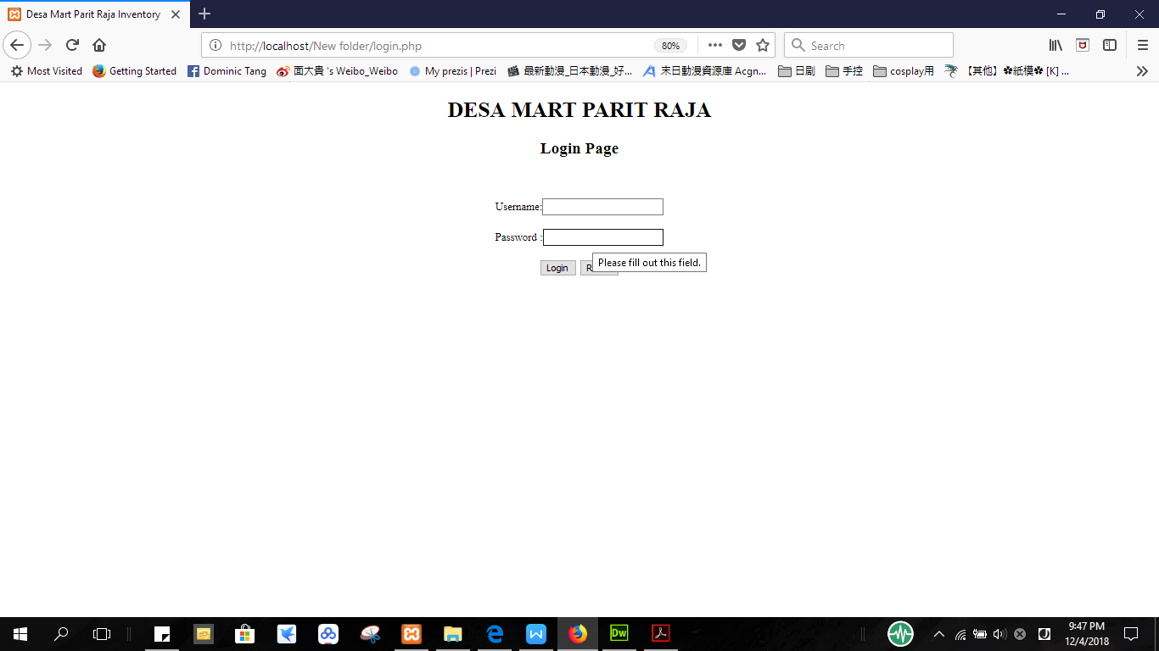

Figure 5.2.5.2 Home Page

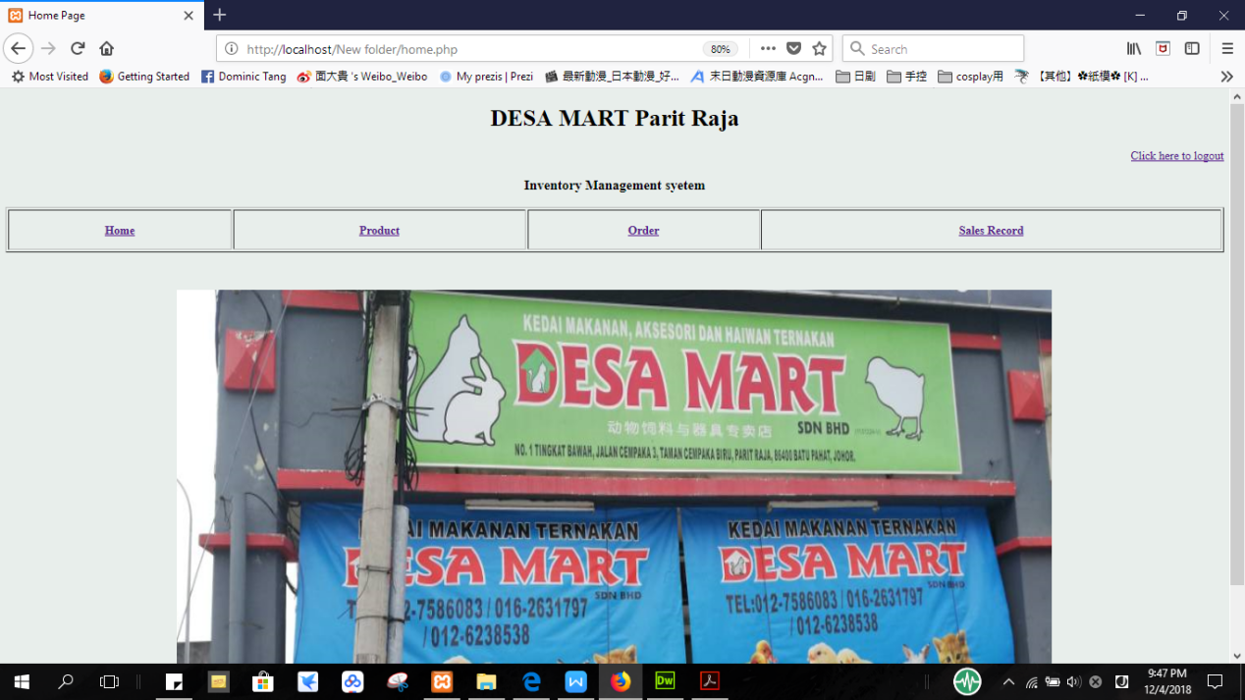

Figure 5.2.5.3 Product Page

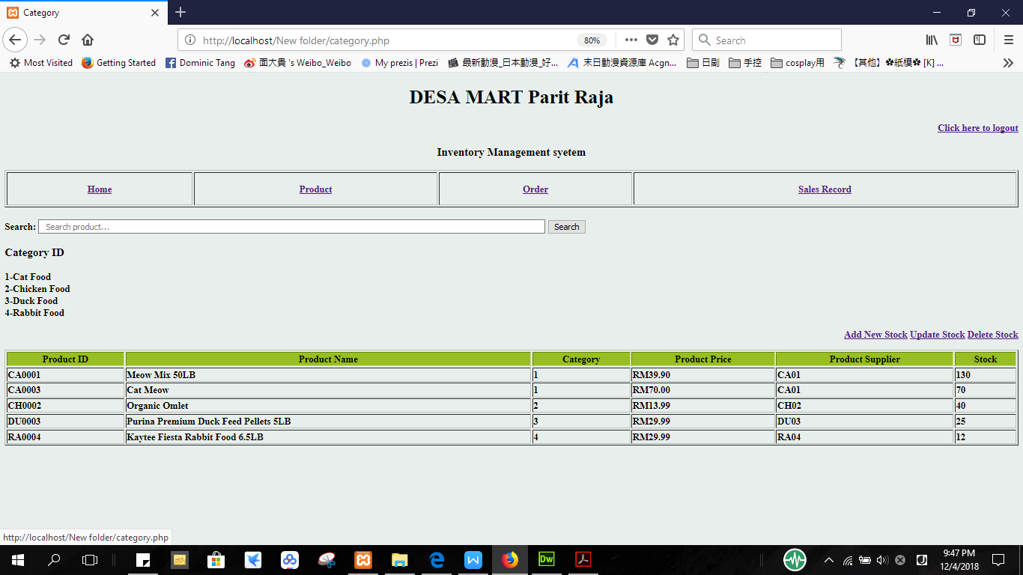

Figure 5.2.5.4 Add New Stock Page

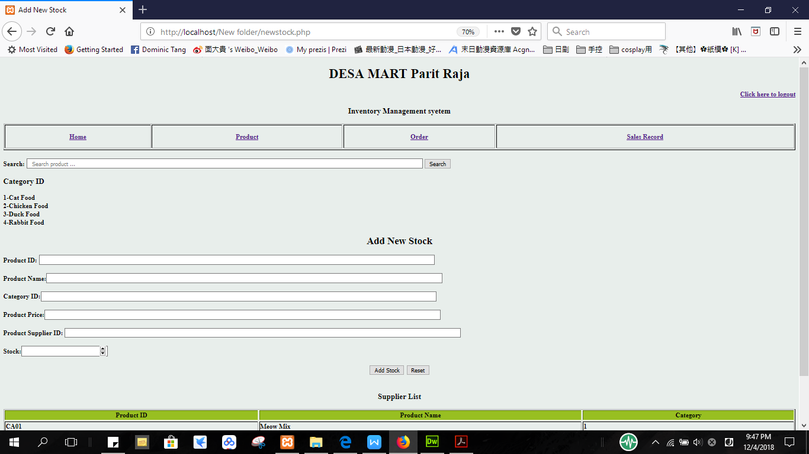

Figure 5.2.5.5 Update Stock Page

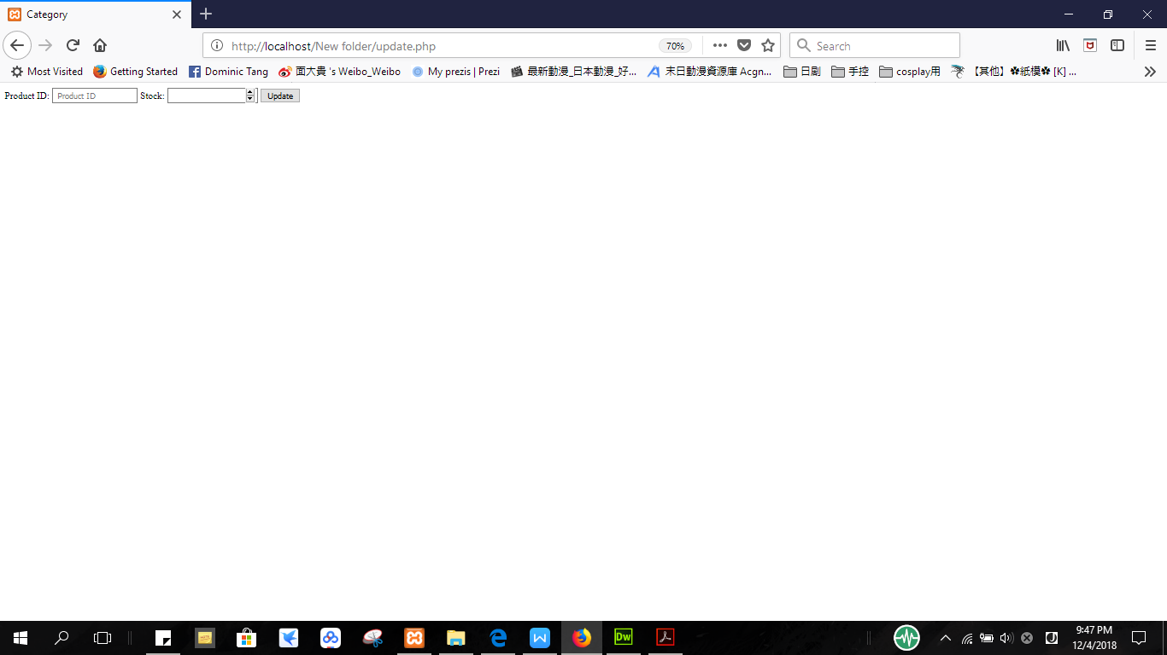

Figure 5.2.5.6 Delete Stock Page

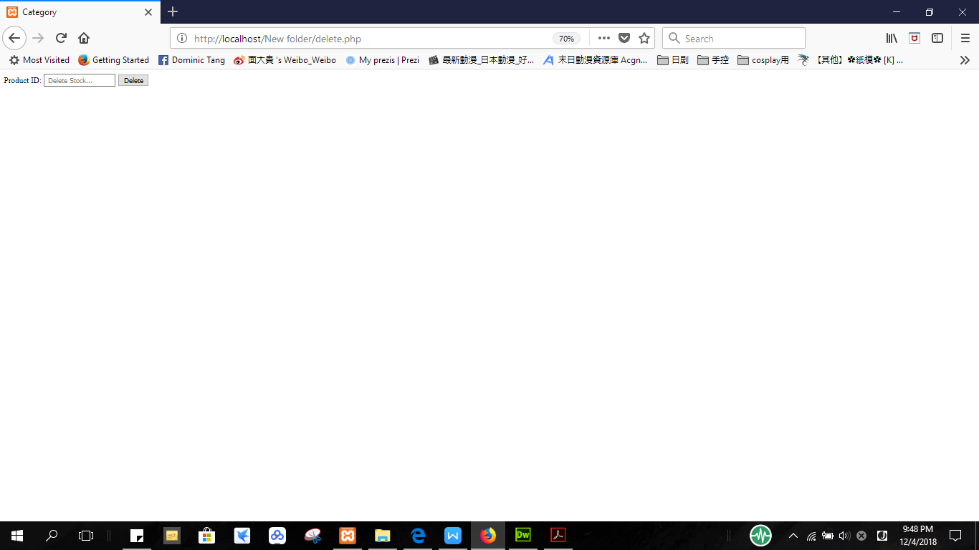

Figure 5.2.5.7 Order Page

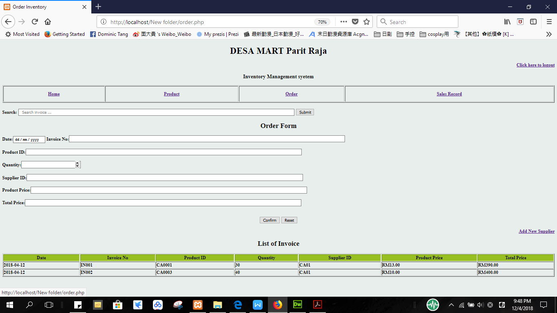

Figure 5.2.5.8 Add New Supplier Page

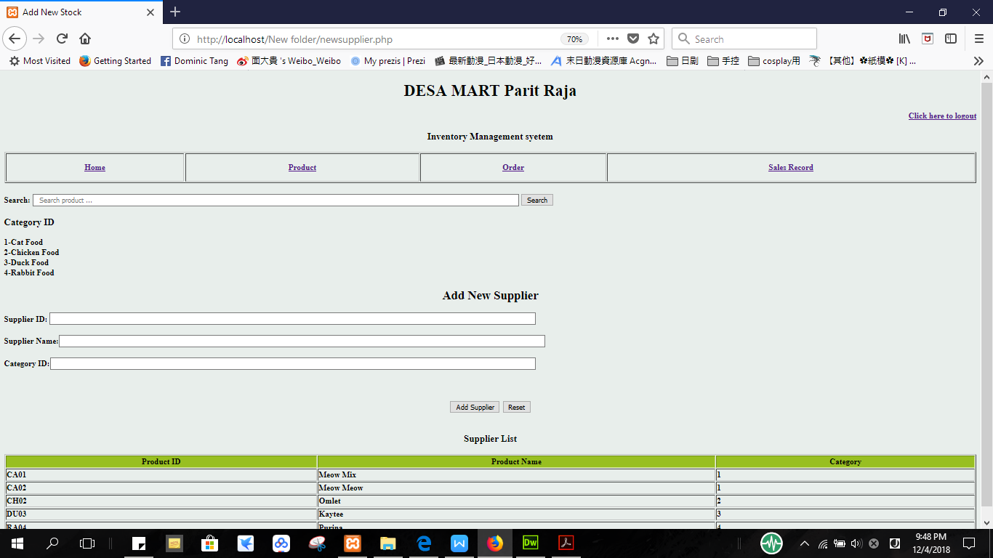

Figure 5.2.5.9 Sales Record Page

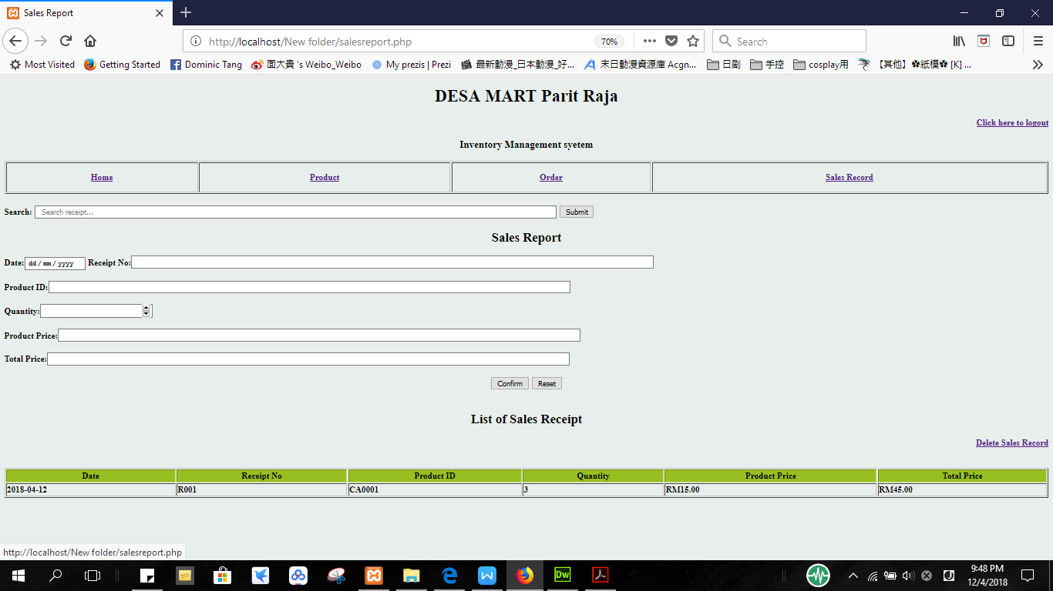

Figure 5.2.5.10 Delete Sales Record Page 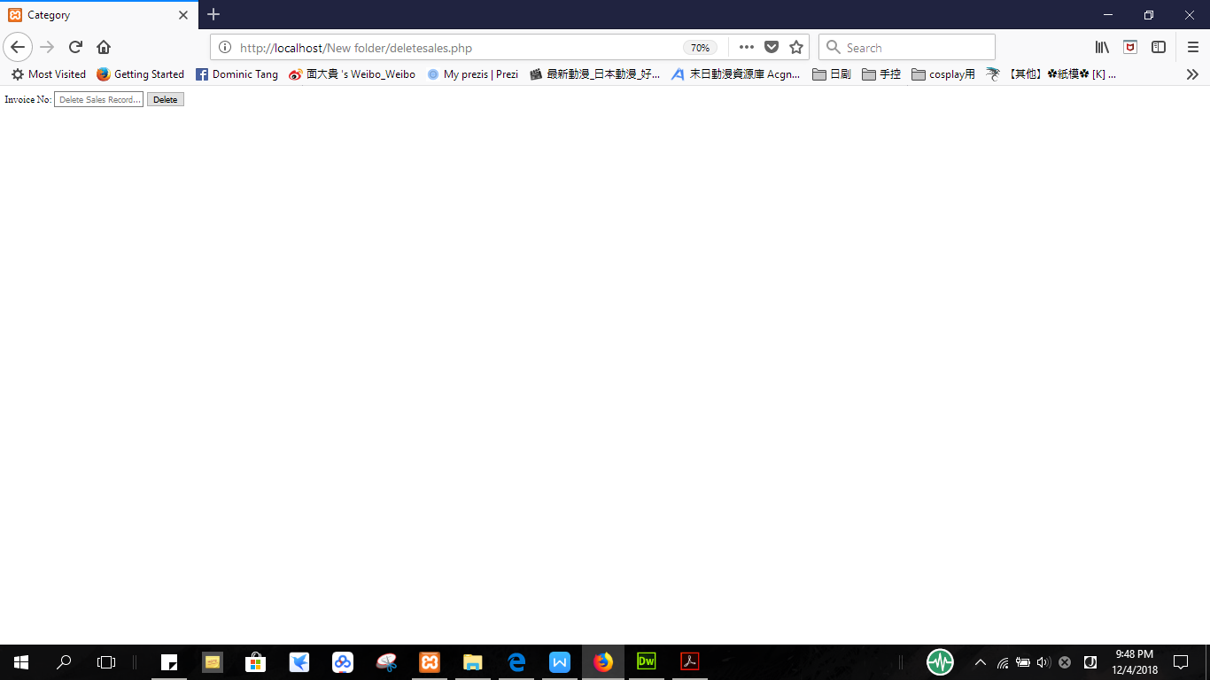

**CHAPTER 6: PROJECT IMPLEMENTATION**

**6.1 Requirement Specifications for Project Development**

## Purpose

This system is to help DESAMART SDN.BHD Company to manage their sales records and inventory digitally which the data will sorted by dates and the owners can view or search the particular report easily.

## Product Scope

The system allows user to navigate through the system easily and allow the user to create, read, update and delete the data in the inventory system. The system will keep the data in secure state all the time and users can access the data anytime they need. For order record, it will have a clear list of date, invoice no, product ID, quantity of ordered stock, supplier, product price and total price in ordering stock. The designed system will show the sales records of the store. For sales record, it will have a clear list of date, receipt no, product ID, quantity of product bought by customer, product price and total price to pay of sales. For the inventory, it will have a clear list of product name, product ID, category, number of stock and suppliers. The user can directly search for the stocks information easily.

## Product Perspective

The inventory system for DESAMART.SDN.BHD is a new system that has never been used by the store before. This system was built to improve the data management for sales and inventory that was done manually all these times. In order to reduce the workload, the sales report will be listed by date and owner can search for particular data based on the characteristics of the products using search engine. This system can also improve the security of the data since all the data will keep in system safely and it only can be accesses by admin using password compare to previous method which data record in log book manually.

## Product Functions

* User will be able to create, read, update and delete the data freely using this system.
* User will be able to keep the order record, sales record and inventory records in secure state.
* User will be able to search the product, invoice and sales record by typing the characteristics of the product or record information in search engine.
* User can view the sales report and refer the report anytime.

## User Classes and Characteristics

The user should be able to know the function such as create new stocks, new orders, and new sales records. The user also requires knowing the function of search engine so that they can search the products by typing the characteristic in search engine. The user also should be able to know how to delete the sales and insert the new sales record in case the user inserts the wrong data.

## Operating Environment

The system will operate offline as it is using local host.

## Design and Implementation Constraints

One major constraint is that the system cannot be accessed through mobile devices and smartphones as it only allows desktop version to access the system. Besides, this system can only apply to one local host which allows the user to access the system through one specific computer to access the database.

# Functional Requirement

## Product Management Feature

* 1. The system will allow management teams to create the new sales record.
  2. The system will allow management team to read the new sales record after the record is updated.
  3. The system will allow the management team to update the information of the sales records in the inventory system.
  4. The system will allow changes to be made by the management team such as delete the wrong sales record and add new suppliers in the database.
  5. The system will allow user to search for products based on their characteristics and date.
  6. The system will enable management team to sort the items by its own characteristic. For example, the products will be sorted based on products ID and the sales record will be sorted based on receipt number while the order record will be sorted by invoice number.

1. Report Management Feature
   1. The system will keep all the sales record in secure state.
   2. The system will be able to update the stock of each product when user order for the stock.
   3. The system will be able to update the inventory when the product is sold.

# Other Nonfunctional Requirements

1. Operational
   1. The system should run on PCs used by the management team.
   2. The system should connect to the database automatically so that any change for the sales record will directly change in the database of the inventory system.
2. Performance
   1. The system should support large amount of data in one database.
   2. The system should be updated with sales record and inventory records anytime.
3. Security
   1. Only the admin is allowed to access and update the system.
   2. Only the admin is allowed to delete sales records in the system.
4. Cultural and Political
   1. Sales and inventory records are protected in which only the admin is allowed access to the data.

**6.2 System Implementation Process**

**6.2.1 Database**

For the database, the system is using phpMyAdmin to create a localhost database as it is only for the admin to create, read, update and delete data offline. The database name is ‘first_db’, it consists of 6 table data.

Figure 6.2.1.1 User table data

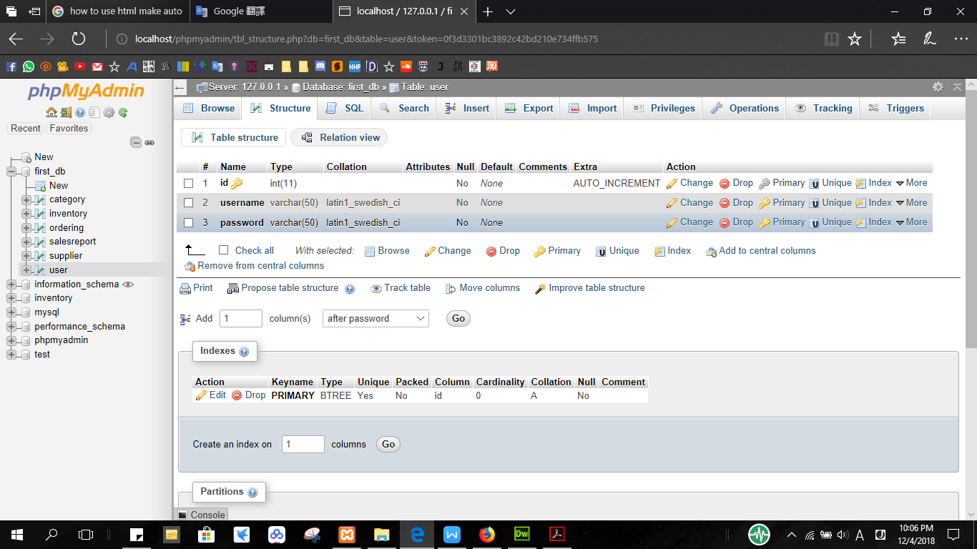

This is the table data to keep the user information that used to login to the Home interface.

Figure 6.2.1.2 Supplier table data

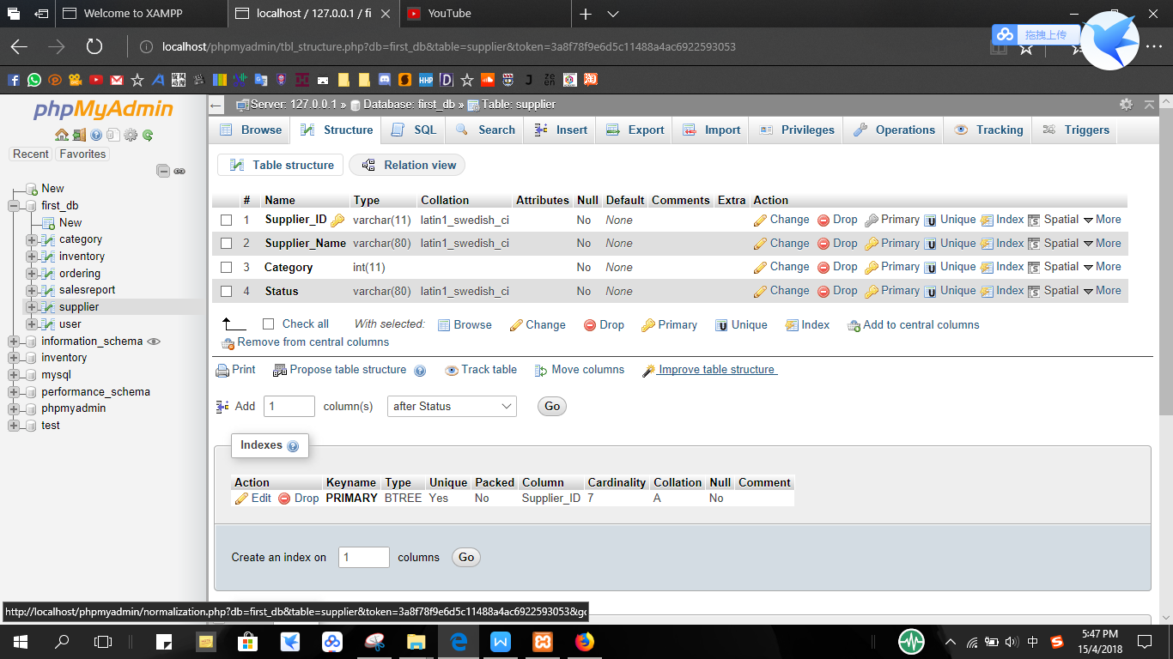

This is the table data to keep the supplier information with the ‘Supplier_ID’, ‘Supplier_Name’ and ‘Category’.

Figure 6.2.1.3 Category table data

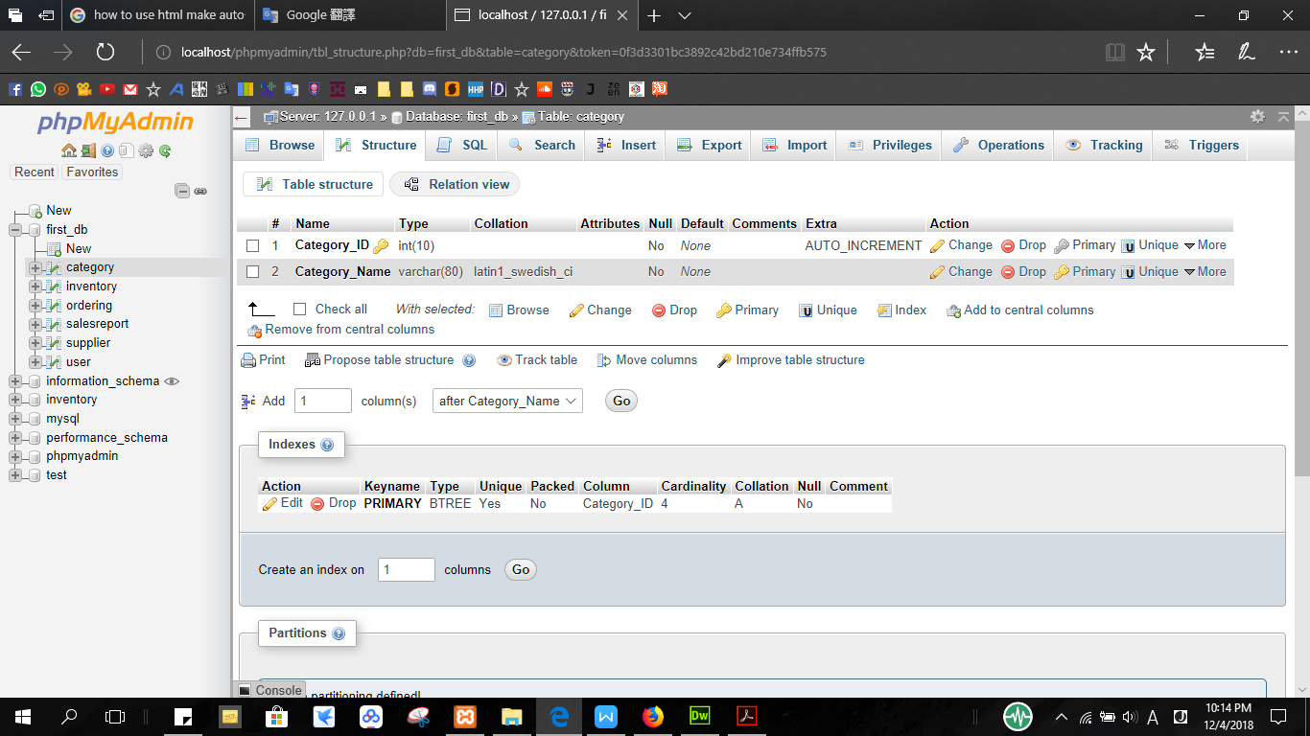

This is the table data to keep the Category Information with the ‘Category_ID’ and ‘Category_Name’. The ‘Category_ID’ is the primary key.

Figure 6.2.1.4 Inventory table data

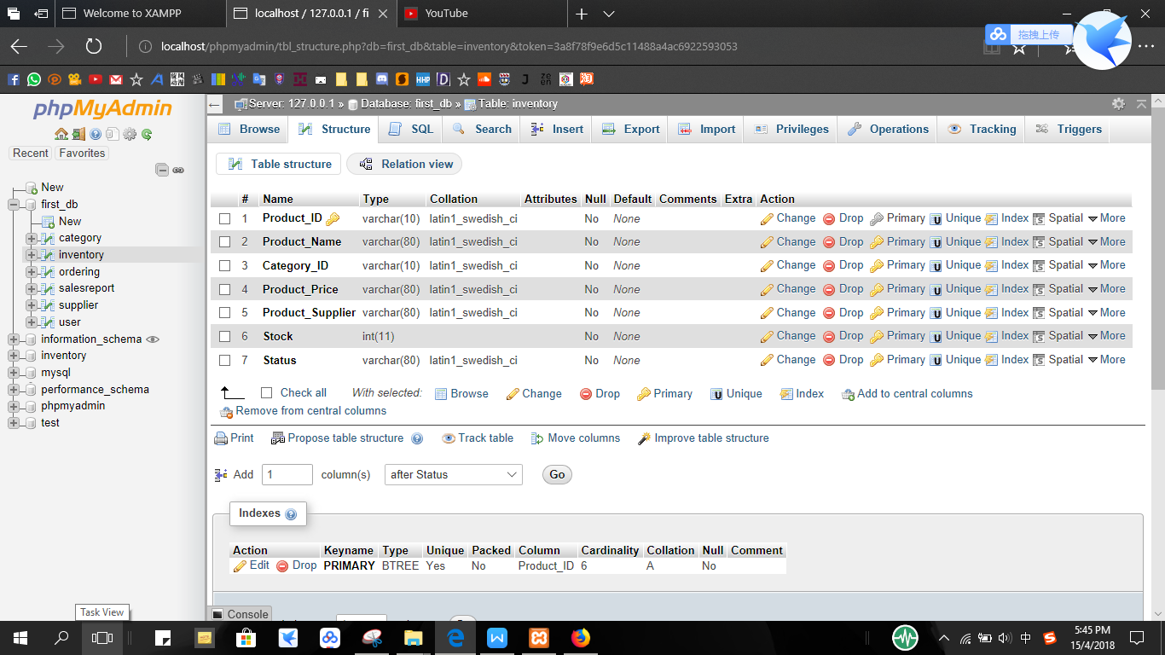

This is the table data to keep the inventory record with the ‘Product_ID’, ‘Product_Name’, ‘Category_ID’, ‘Product_Price’, ‘Product_Supplier’, and ‘Stock’. ‘Product_ID’ as the primary key, ‘Category_ID’ has the internal relation with ‘Category_ID’ from the category table data while ‘Product_Supplier’ has the internal relation with ‘Supplier_ID’ from the supplier table data.

Figure 6.2.1.5 sales report table data

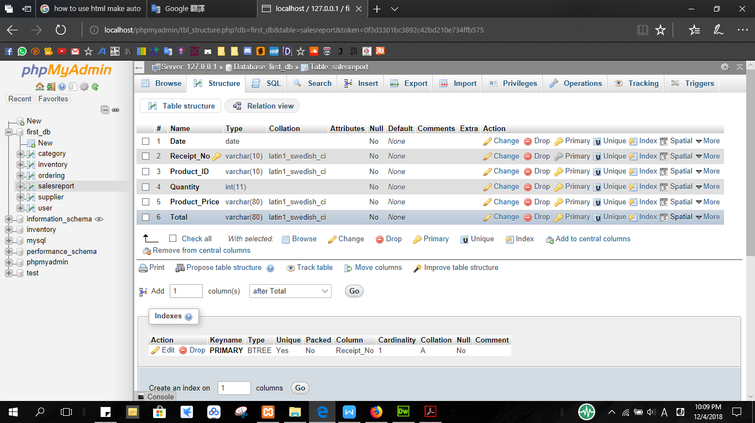

This is the table data to keep the sales record with the ‘Date’, ‘Receipt_No’, ‘Product_ID’, ‘Quantity’, ‘Product_Price’ and ‘Total’. ‘Receipt_No’ as the primary key and ‘Product_ID’ has the internal relation with ‘Product_ID’ from the inventory table data.

Figure 6.2.1.6 ordering table data

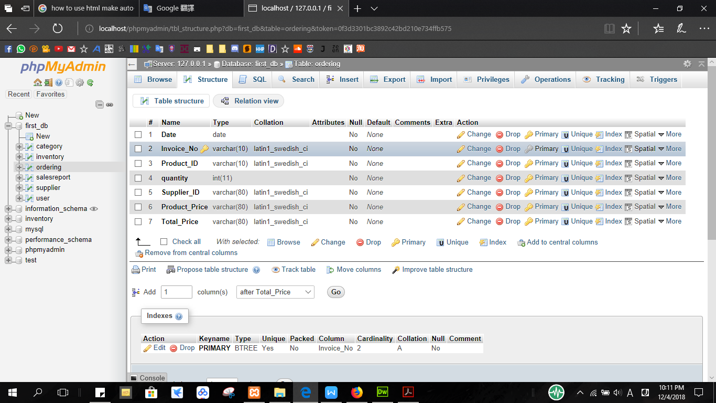 This is the table data to keep the order record with the ‘Date’, ‘Invoice_No’, ‘Product_ID’, ‘quantity’, ‘Supplier_ID’, ‘Product_Price’ and ‘Total_Price’. ‘Invoice_No’ as the primary key, ‘Product_ID’ has the internal relation with ‘Product_ID’ from the inventory table data while ‘Supplier_ID’ has the internal relation with ‘Supplier_ID’ from the supplier table data.

**6.2.2 PHP coding**

To connect to the database, this system use php coding and create a user interface for the user to manage the data from the database.

Figure 6.2.2.1 login.php

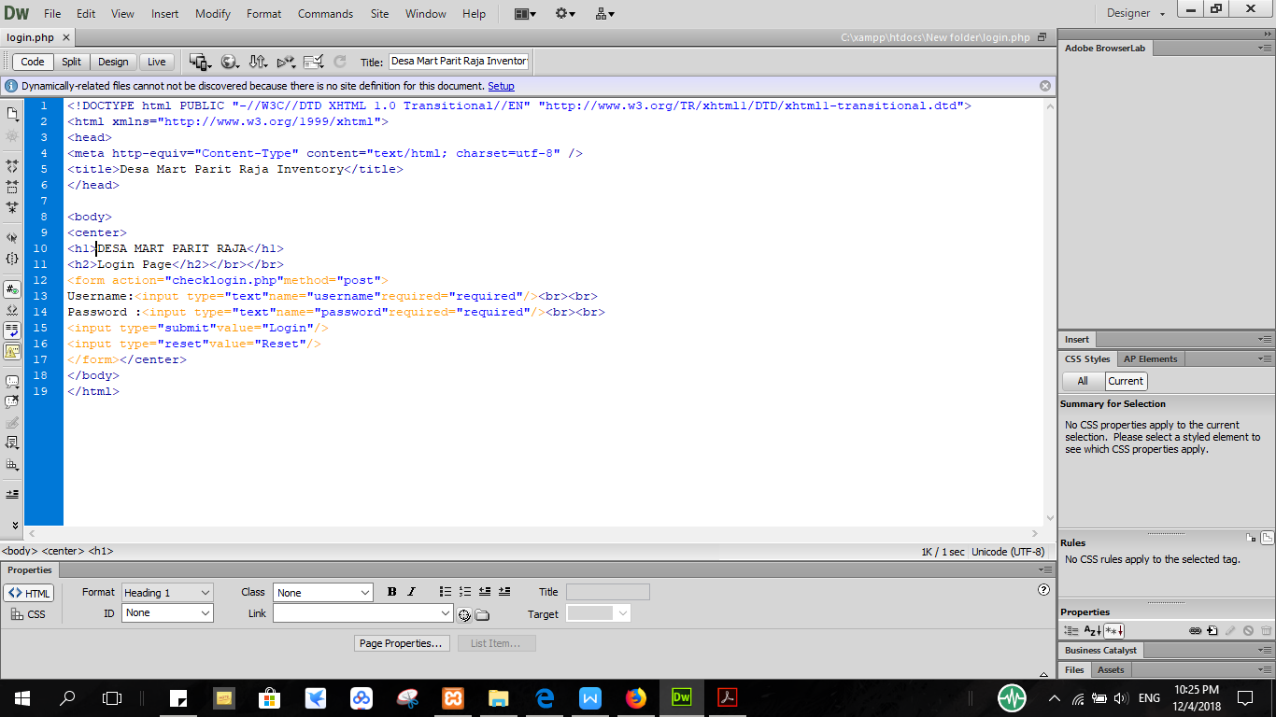

We used the html coding to create the login interface and create a form to let the user input the username and password and link to the php coding file using the form action.

Figure 6.2.2.2 checklogin.php

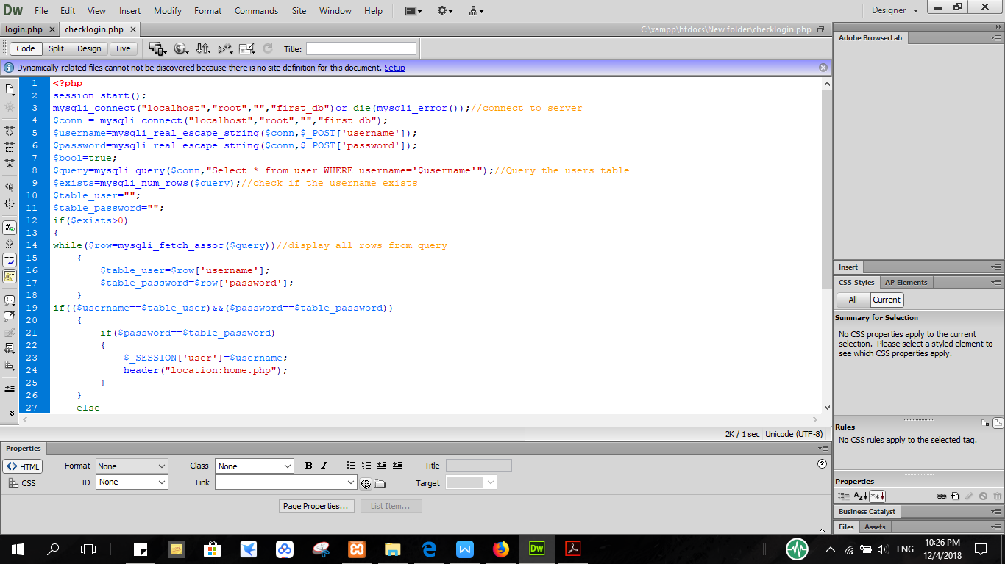

The code above is about using the php coding to check for the username and password that user input is match with the data in the user table data in first_db database. The mysqli_real_escape_string() function escapes special characters in a string for use in an SQL statement.The PHP superglobals $_POST are used to collect form-data. The mysqli_query() function performs a query against the database. The mysqli_num_rows() function returns the number of rows in a result set. The mysqli_fetch_array() function fetches a result row as an associative array, a numeric array, or both.

Figure 6.2.2.3 checklogin.php (error part)

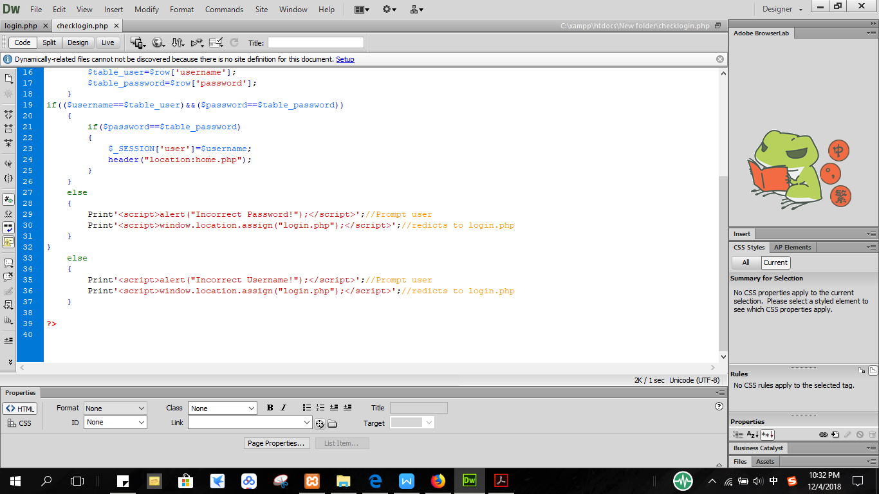

<script>alert(“Incorrect Username！”);</script> is to give a alert window to the user if the user input wrong username. ‘header(“location:home.php”) the coding set that the user interface will turn into home page if the user successfully login. ‘window.location.assign(login.php)’ set that if user press OK when the alert window pop out because of wrong input username or password it will return to the login page.

Figure 6.2.2.4 category.php

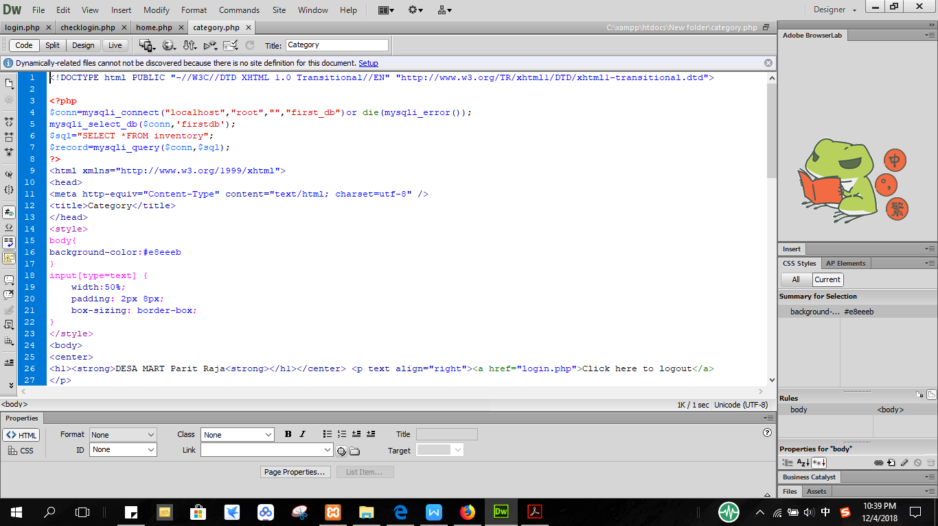

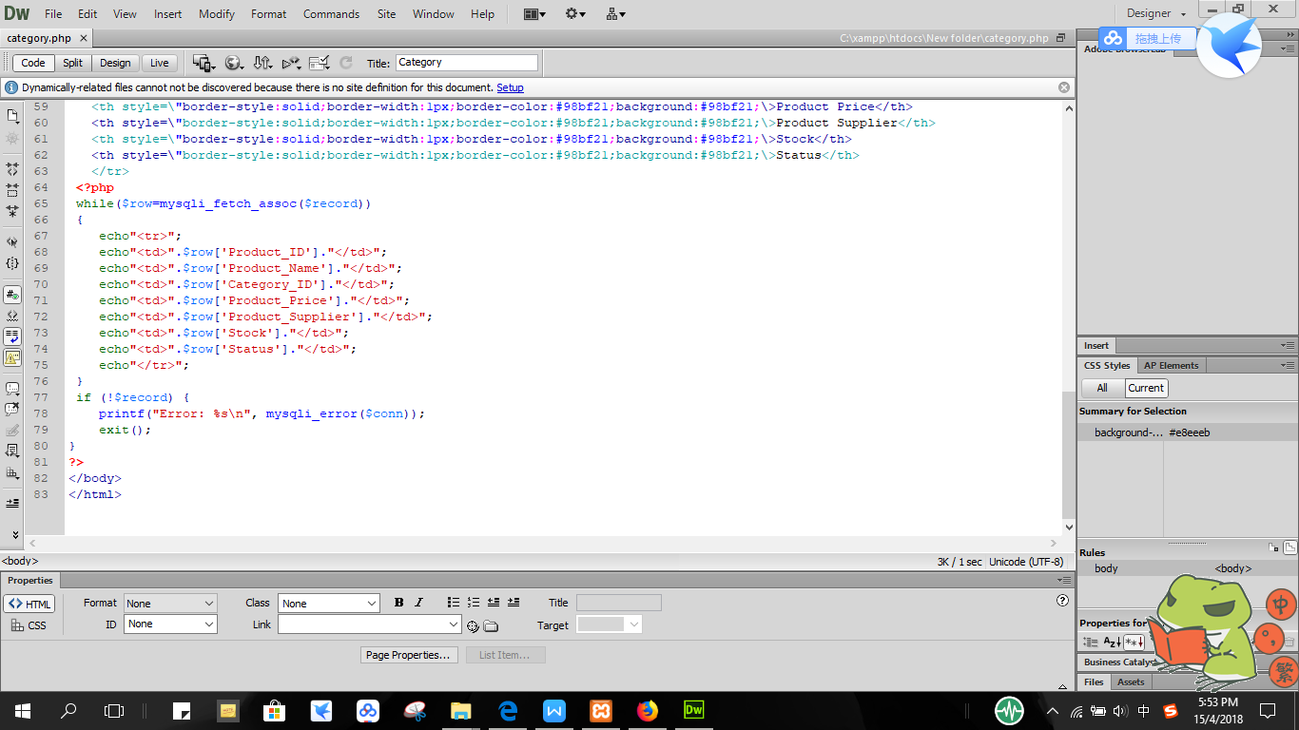

The coding above show that it is using mysqli_connect to connect to the database which is ‘first_db’ and $sql select the table data from the database that will be use to display in the user interface. mysqli_fetch_assoc is used to fetch the data while there is any data that exists in the table data and echo is a print out function to display out the data information. mysqli_error() function returns the last error description for the most recent function call, if any.

Figure 6.2.2.5 category.php (search engine)

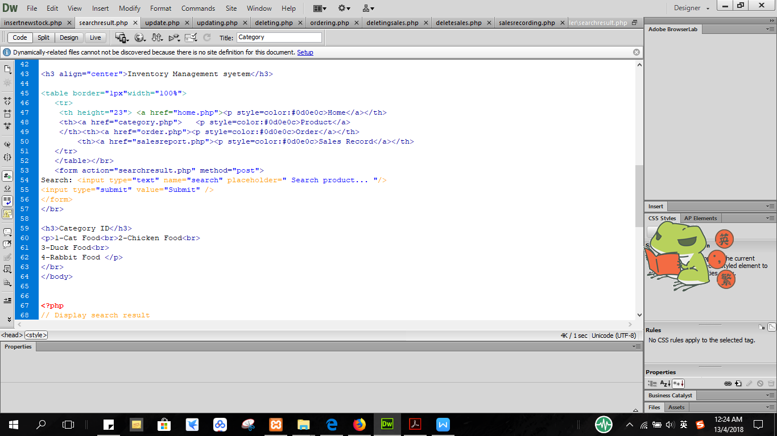

The coding above is use for the search engine function. The form is created for user to input the text to search. The form action is relate to searchresult.php which will connect to database to let the user search data from the database.

Figure 6.2.2.6 searchresult.php

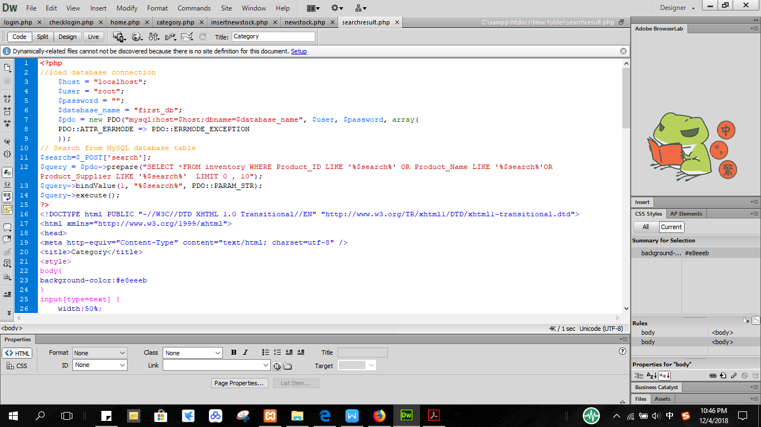

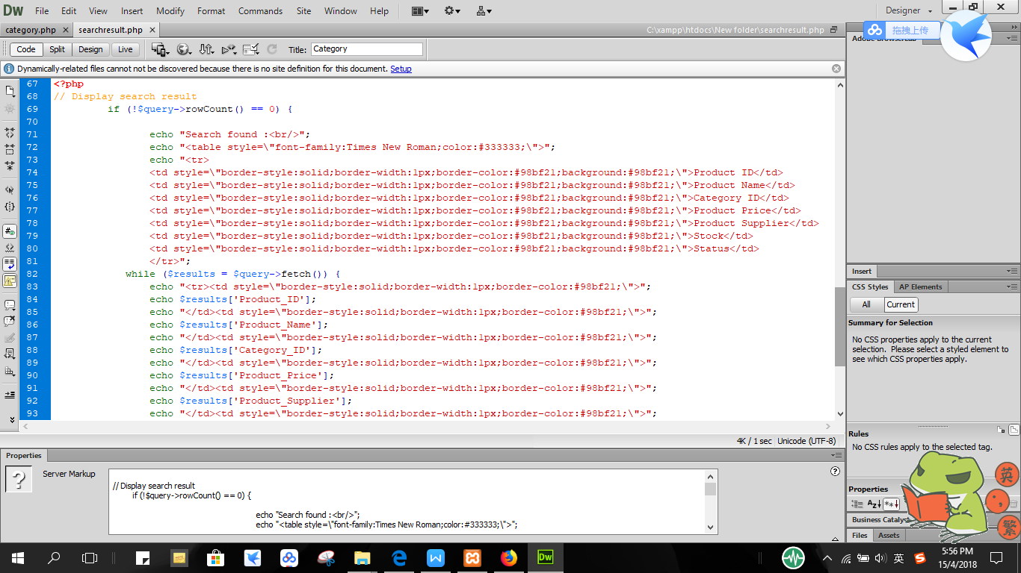

new PDO();accepts parameters for specifying the database source, optionally for the username and password and handle the error message. ‘$pdo->prepare("SELECT *FROM inventory WHERE Product_ID LIKE '%$search%' OR Product_Name LIKE '%$search%'OR Product_Supplier LIKE '%$search%' LIMIT 0 , 10");’ to access the search engine where the user can search the product by input product id, name or supplier id. If the search success it will display the result from the table data that match with user input.

Figure 6.2.2.7 insertnewstock.php

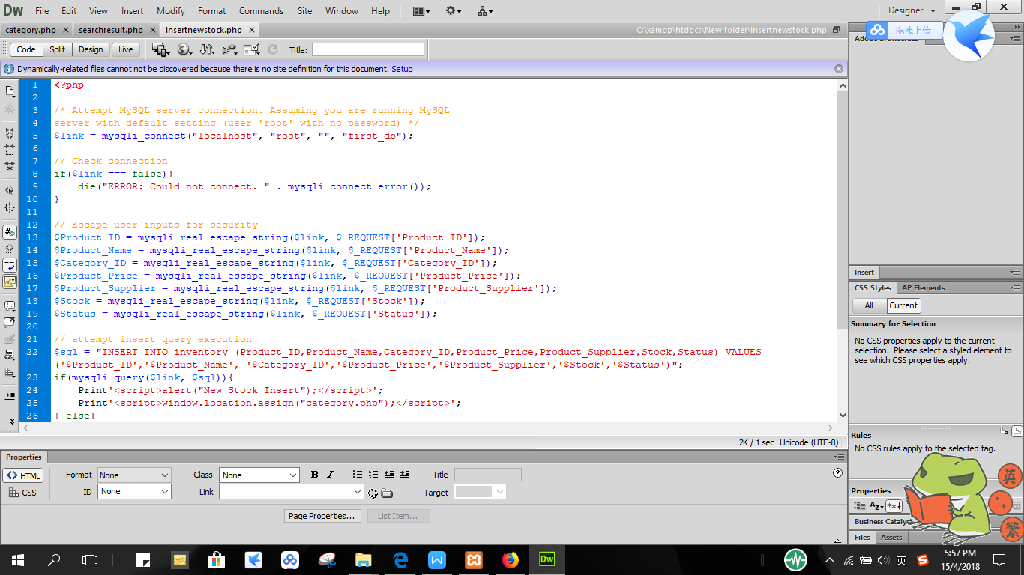

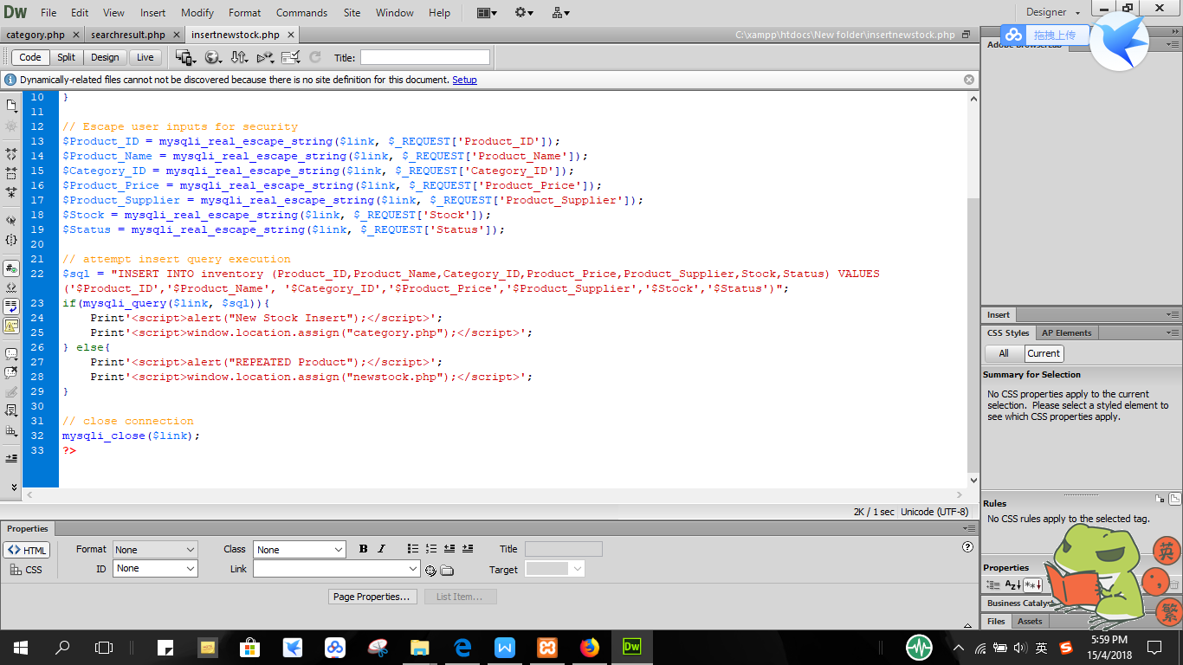

To create a new data, sql is assign with the ‘INSERT INTO table_name(input_values)VALUES(data_name)’ to insert the data into the database and save record. ‘die’ function prints a message and exits the current script if cannot connect to database.

Figure 6.2.2.8 updating.php

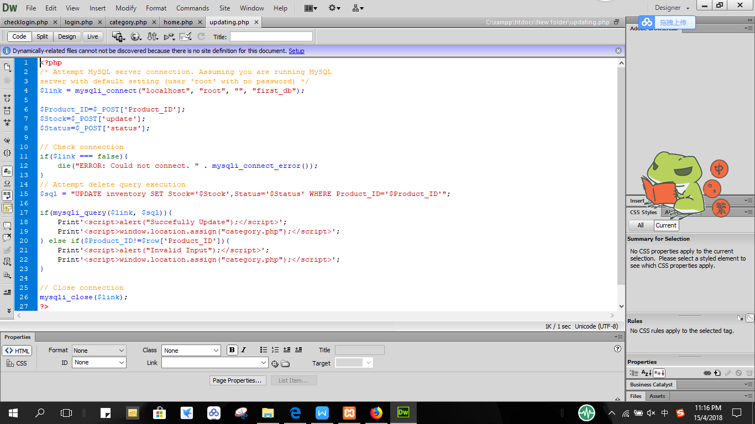

To update the stock, we need to assign ‘UPDATE table_name SET input_value=data_name’ to update the data that user insert from the database.

Figure 6.2.2.9 deleting.php

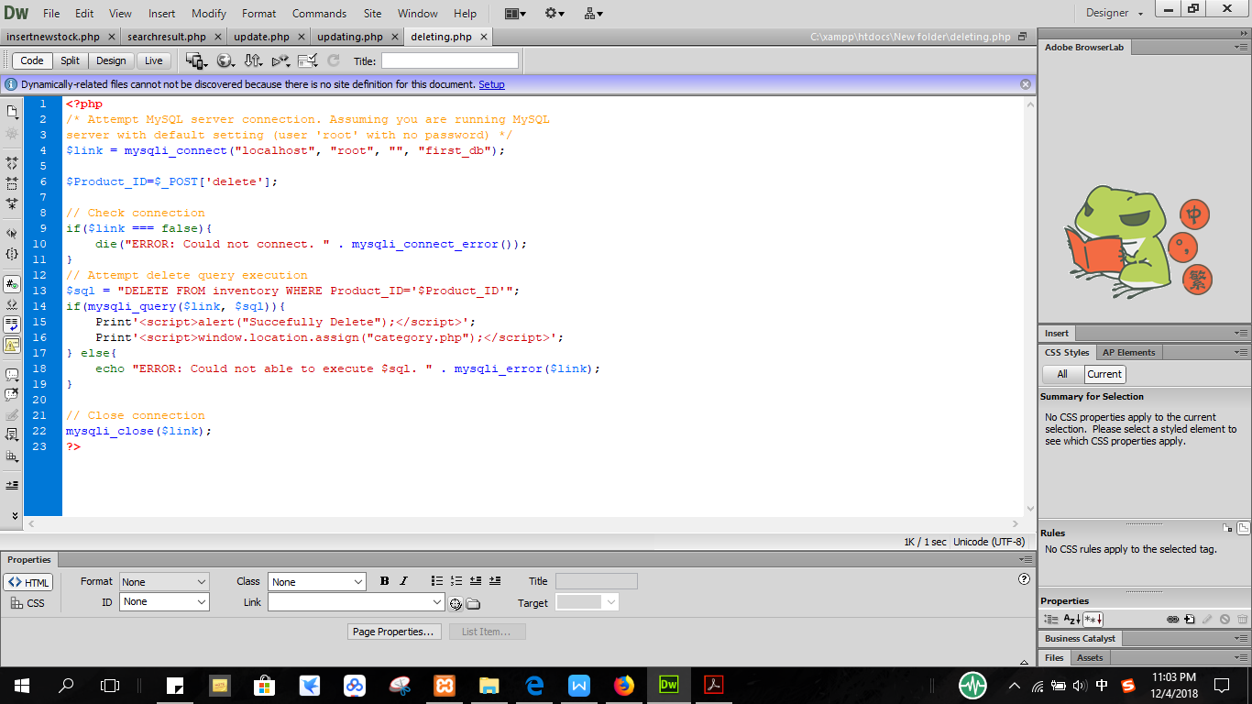

To delete the stock, we need to assign ‘DELETE FROM table_name WHERE input_value=data_name’ to delete the data that user insert from the database.

Figure 6.2.2.10 ordering.php

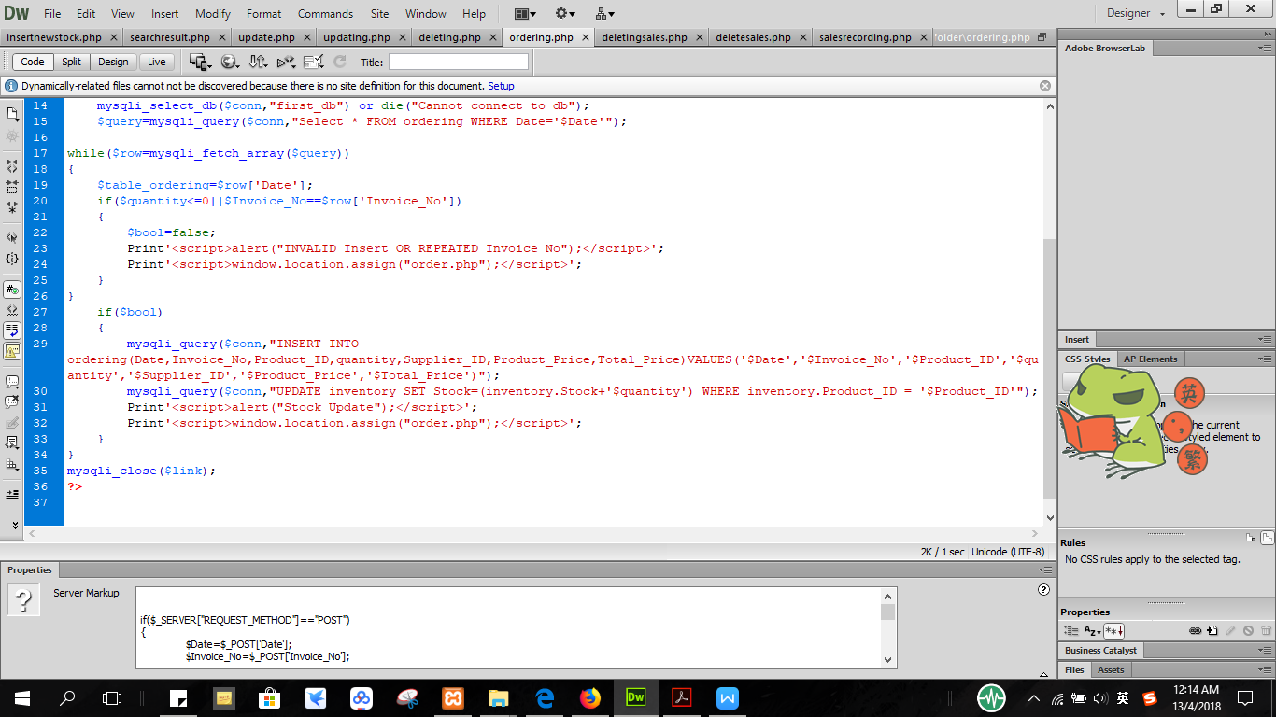

‘mysqli_query($conn,"UPDATE inventory SET Stock=(inventory.Stock+'$quantity') WHERE inventory.Product_ID = '$Product_ID'");’ updates the stock of the product in the table data by adding the current stock and the quantity the user insert in the order record.

Figure 6.2.2.11 salesrecording.php

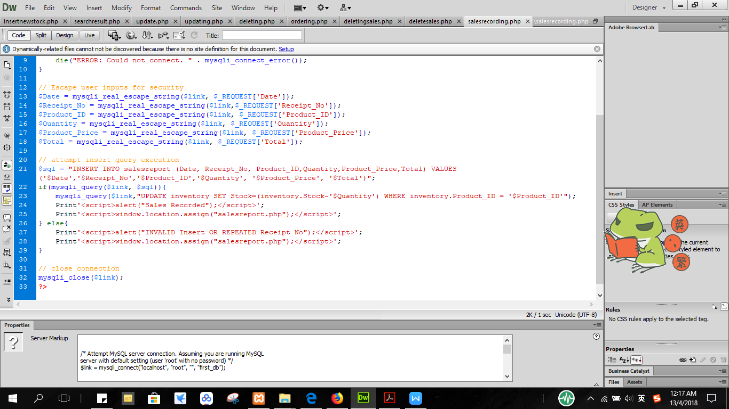

‘mysqli_query($conn,"UPDATE inventory SET Stock=(inventory.Stock-'$Quantity') WHERE inventory.Product_ID = '$Product_ID'");’ update the stock of the product in the table data by subtract from current stock with the quantity the user insert in the sales record.

**6.3 Hardware and software requirements**

These are list of software and hardware that used in this project.

Table 6.3.1 Software Requirement

|  |  |
| --- | --- |
| Software | Usage |
| Operating System: Windows 10 | To control the all of the process and application software in computer |
| Xampp (PhpMyAdmin) | To create the database system |
| Dreamweaver | To create the user interface using php coding |
| Snipping Tools | To get certain part of figures |
| Windows Media Player | To hear the interview recorded |
| Windows Image Viewer | To see the picture taken in the company |
| Google Chrome | To search additional information from the internet |
| Acrobat Reader | To read PDF files |
| Microsoft Word 2016 | To write proposal and final report |
| Microsoft Project 2013 | To create Gantt Chart |

Table 6.3.2 Hardware Requirement

|  |  |
| --- | --- |
| Hardware | Usage |
| Desktop | To finish the project and store all of the data |
| Keyboard | To input the words to make proposal and final report |
| Printer | To print out the report and proposal |
| Speaker | To hear the recorded interview session |
| Mouse | To navigate the mouse pointer |

**CHAPTER 7: MAINTENANCE**

* 1. **Weaknesses of the system/project**

In this project, the user’s requirement was studied and an inventory management system based on user’s needs was developed. However, there are some weaknesses that may exist in this inventory management system.

Due to the moderate store which only has a few employees, the information on the system might be unreliable if not updated on a regular basis. For example, in order to record all the inventory information,the store need more employees to work on the system to record and manage the system as the inventory is updated by user input manually in the system by computer. The store need to ensure they have enough employees to key in and keep on update the latest data in the inventory system to prevent unreliable information provide to the company. This may consume a lot of time and human resources which the manager of the store should decide properly before using the system.

Besides, due to localhost database system, user only can use the inventory management system in one specific computer and not in others. The user cannot update the inventory in anywhere and anytime if without the computer. However, it can say that the system in this project created had enough basic function for a digital inventory management system.

* 1. **Future Endeavour in the Project**

The entire outcome of the system develop is satisfactory since most of the targets set in this project were reached. The future endeavor in this project is to hope this system can be more convenient to us and save more time than what was expected in this project. Besides, it is hoped that the inventory management system can meet the requirement of the user and after developing the system, hopefully the store can be improved by creating an online database that can be updated anywhere and anytime with the modern technology devices and improvement on the inventory management. It is hoped that this system will be kept up to date and successfully keep the inventory data of the store effectively.

**CHAPTER 8: CONCLUSION**

**8.1 Achieving the Aims of the Programs**

In conclusion, our team had decided to create a system which can improve the company’s current systems to serve their business needs. This decision was based on the research done in Desa Mart in Parit Raja in which the store does not have any database system specially to keep their inventory information and sales records. Hence, it was decided to create a computer-based inventory system which will help to safe-keep its records and is considered one of the biggest expectations in this project. Besides, the owner will be able to find past year records easily by using the system’s search engine. This also might help boost the effectiveness and in turn help the store keep their information more organized. This can directly help in increase effectiveness in managing the inventory and search for a particular sales report because this system can be accessed digitally which can save a lot of time and work. Unlike the previous manual inventory management system, the manager had to search the sales record manually in a log book. This computer-based inventory system will help in displaying the stocks when the admin searched the particular stocks from search engine. This system in other words can keep the information and records in secure state since it can improve backup and recovery service as compared to the manual recording method. From the process of building the inventory system in this project, our team learns to think further to increase the mission success rate and achieved the aims of the program.

**8.2 Advantages of the system/ project**

Although there are some weaknesses exist in this project, however, the advantages can still clearly be seen from the system built in this project. The most obvious advantage of the inventory system is the potential for organizing the sales report and inventory record in more effective and easier manner. Hence, this designed inventory system will help to safe-keep all the sales and inventory reports so that only admin can make change and access to the system anytime.

The other advantage is admin can save lots of time finding the previous data because when the admin type in the keyword in search engine, the stocks data will be automatically displayed. Besides, if the admin inserts the wrong sales records, there is a delete function which the admin still can make change by deleting the previous sales data and insert the new one. This system is designed to operate 24 hours because the system is offline in which internet connection is not required. This means that admin can easily access to the system with correct username and password to make changes in the inventory management system when necessary.

**Reference**

1. Special Topics in Computer Science: Basic Concepts, University College Cork, Ireland, October 15th 2009, <http://www.cs.ucc.ie/pipermail/cs2501/attachments/20091015/a1d4fcea/attachment-0004.pdf>
2. GCSE Bitesize, Database and Data Capture, BBC, 2014, <http://www.bbc.co.uk/schools/gcsebitesize/ict/databases/2databasesrev4.shtml>
3. [Jason Gilmore](https://www.developer.com/author/Jason-Gilmore-84750.htm), Creating a Code Search Engine with PHP and MySQL, April 11, 2007 <https://www.developer.com/db/article.php/3671021/Creating-a-Code-Search-Engine-with-PHP-and-MySQL.htm>
4. [Dynamic Zones International B.V](http://www.dynamiczones.com/), Introduction or a tale of how easy a search engine could work, 2008 <https://www.dmxzone.com/go/14246/free-how-to-build-a-php-search-engine/page2.htm>
5. W3Schools, PHP 5 Tutorial, [Copyright 1999-2018](https://www.w3schools.com/about/about_copyright.asp) by Refsnes Data. <https://www.w3schools.com/php/default.asp>
6. [The PHP Group](http://php.net/copyright.php)Connections and Connection management2001-2018 [CoderCruise 2018 - The Bahamas!](http://php.net/conferences/index.php" \l "id2018-04-11-1) <http://php.net/manual/en/pdo.connections.php>
7. [Creative Commons Attribution-NonCommercial-ShareAlike](https://creativecommons.org/licenses/by-nc-sa/3.0/deed.en_US" \t "https://www.w3resource.com/mysql/aggregate-functions-and-grouping/_blank)MySQL SUM() function Last update on April 03 2018 07:31:44 (UTC/GMT +8 hours) 3.0 Unported License. <https://www.w3resource.com/mysql/aggregate-functions-and-grouping/aggregate-functions-and-grouping-sum().php>
8. [Jamier101](https://www.webmasterworld.com/profile/Jamier101/" \t "https://www.webmasterworld.com/php/_blank" \o "Click to View Profile), Undefined index error, what does it mean?, 10:48 am on Mar 22, 2011 (gmt 0), Webmaster World, <https://www.webmasterworld.com/php/4285580.htm>
9. [maelienel](http://www.dreamincode.net/forums/user/547290-maelienel/?s=b60a70fcdd3af5f54a62276e9b8cc3d8), [edit data in database using php](http://www.dreamincode.net/forums/topic/250097-edit-data-in-database-using-php/?s=b60a70fcdd3af5f54a62276e9b8cc3d8), Posted 06 October 2011 - 04:26 AM, <http://www.dreamincode.net/forums/topic/250097-edit-data-in-database-using-php/>
10. Beta Tester, update stock qty using mysqli, 6/22/2017 6:31 am, WebAssist.com Corporation <http://www.webassist.com/forums/posts.php?id=40221>
11. plus2net.com, Calculating and storing SUM of a column in another table <http://www.plus2net.com/sql_tutorial/sql_insertsum.php>
12. [csk157](https://owlcation.com/stem/Simple-search-PHP-MySQL), [Simple Search Using PHP and MySQL](https://owlcation.com/stem/Simple-search-PHP-MySQL), Updated on April 30, 2016 HubPages Inc. <https://owlcation.com/stem/Simple-search-PHP-MySQL>
13. [masinosinaga](http://sourceforge.net/u/masinosinaga/) ,Stock Inventory Management, PHP Stock Inventory Management System - POS, Slashdot Media <https://sourceforge.net/projects/stock-inventory-management/?source=typ_redirect>
14. [Webslesson](http://www.webslesson.info/), [Source Code of PHP Inventory Management System](http://www.webslesson.info/p/source-code-of-php-inventory-management.html), PHP, MySql, Jquery, AngularJS and Ajax Tutorial <http://www.webslesson.info/p/source-code-of-php-inventory-management.html>
15. Tutorial points , PHP - MySQL Login, [Tutorials Point (India) Pvt. Ltd.](https://www.youtube.com/channel/UCVLbzhxVTiTLiVKeGV7WEBg" \t "https://www.youtube.com/_blank) https://www.tutorialspoint.com/php/php_mysql_login.htm

**Attachment 3: Turnitin Check Similarity less than 25%**

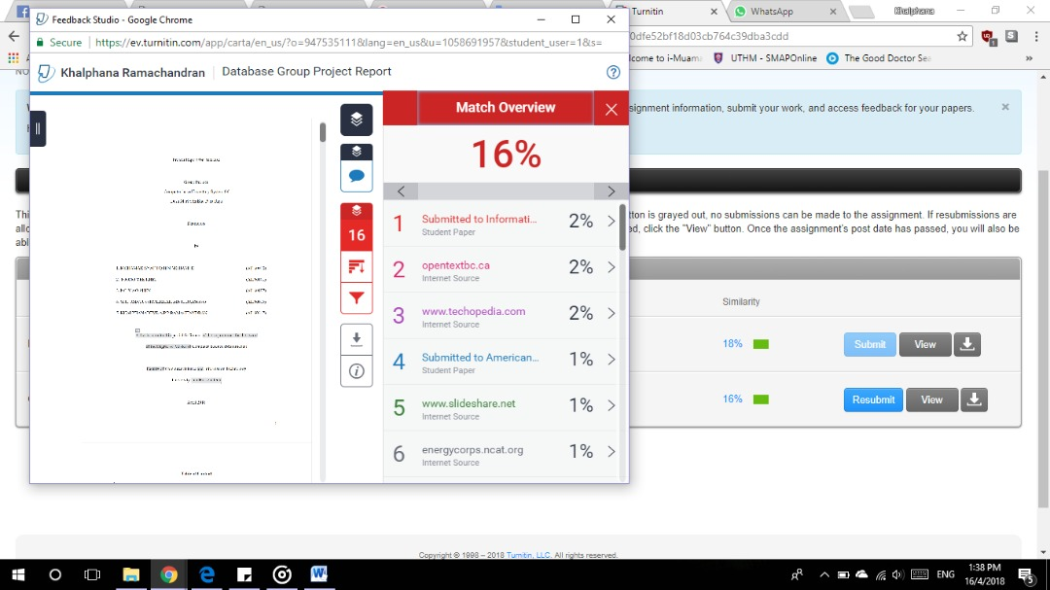

1. Special Topics in Computer Science: Basic Concepts, University College Cork, Ireland, October 15th 2009, http://www.cs.ucc.ie/pipermail/cs2501/attachments/20091015/a1d4fcea/attachment-0004.pdf
2. GCSE Bitesize, Database and Data Capture, BBC, 2014, http://www.bbc.co.uk/schools/gcsebitesize/ict/databases/2databasesrev4.shtml